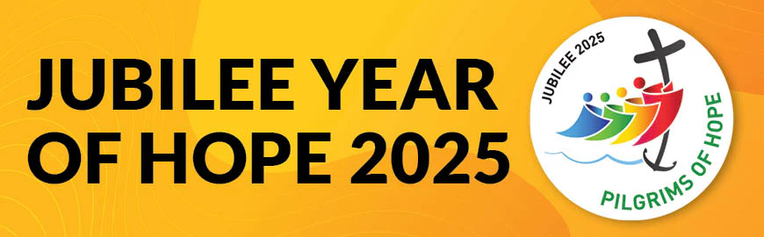

# The Year will run from the opening of the Holy Door at St Peter’s Basilica on Tuesday 24th December 2024 to the Solemnity of the Epiphany 2026

# At Saint Patrick’s this year we will…

|  |  |  |  |  |  |  |  |
| --- | --- | --- | --- | --- | --- | --- | --- |
|  | Create Hearts of Hope and Kindness |  | Become Pilgrims of Hope |  | Think of our School, Parish and Global Communities |  |  |

|  |  |  |
| --- | --- | --- |
|  |  | Calendar Academic Year 2024-2025 |
| January 2025 | | **Launch Day Jubilee Year of Hope – Friday 24th January 23, 2025**   * Colourful Mufti day * Children, staff and parents make ‘Hearts of Hope and Kindness’ to display * Classes receive Official Icon to display for year (Ethiopia)and Luce class keyring * Staff, governors receive cross as symbol of Year of Hope |
| February 2025 | | * Years 5 and 6 Mass at Saint Patrick’s Church * Father Michael to Visit Reception and Key Stage 1 – theme ‘Year of Hope and Pilgrimage’ * Fundraiser ‘Be Part of Team Tom’ for inspirational past student |
| March 2025 | | * Years 3 and 4 Mass at Saint Patrick’s Church * Reception and Key Stage 1 onsite ‘Pilgrimage of Hope’ – led by Year 6 * Year 5 Kilve Residential – theme Year of Hope * Lent Acts of Hope and Kindness – Footsteps in faith badges |
| April 2025 | | * Easter – complete Acts of Hope and Kindness – Footsteps in faith badges * Stay and Pray Week – all families invited to stay and pray/chat every morning Mon. 31st April – Fri. 4th May 9am – 9.30am * The Jubilee Icon is tour - 28th-30th April at St John the Evangelist, Bath |
| May 2025 | | * Key Stage 2 Pilgrimage to local Corsham Churches – linked to Corsham Walking Festival * Rosary – Hope focus * Father Craig to visit school to discuss theme of Hope * Father Michael to Visit Reception and Key Stage 1 – theme ‘Hope and God’s People’ * The Jubilee Icon is tour - 1st -3rd May: St Nicholas of Tolentino, Bristol   4th-6th May: Holy Rood, Swindon  7th-9th May: Our Lady St Mary of Glastonbury |
| June 2025 | | * Year 6 Leavers Mass @ Clifton Cathedral * Education Mass @ Clifton cathedral * Camino Schools Year of Hope Event – more details to follow |
| July 2025 | | * Jubilee pledges to be made by children, staff and parents * Theme of 'Hope for the Future’ |
| Future Events… | | * New academic year, new hopes and dreams * 4th Oct Saint Francis of Assisi Feast Day ‘Hope for Creation’ * 9th Oct Feast Day of John Henry Newman ‘Heart Speaks unto Heart’ * Jubilee Celebration Day 21st November * Advent with Hope in our Hearts * Jubilee Year officially ends Feast of Epiphany 2026 |

Events highlighted in yellow, will focus on our school community

Events highlighted in green, will focus on the local community

Events highlighted in blue, will focus on the wider or global community

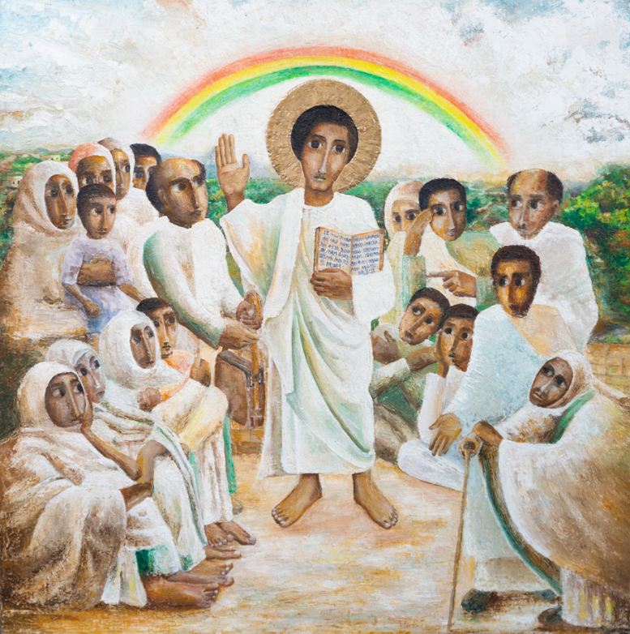

**The Jubilee Icon**

**by**

**Mulugeta Araya**

(Ethiopian artist. Art commissioned for the Catholic Church in England and Wales)



**Meet ‘Luce’** – the Vatican’s official mascot for the 2025 Jubilee.

Luce – translating to ‘Light’ from Italian – represents a Catholic pilgrim