**Home Learning – Year 6**

**Week 1 - Answers**

1. When were the Maya a dominant culture? Around 1000 years before the Aztecs, about 1400.
2. Find two words that tell you that the Maya were educated. Scientific, studied, created
3. How does the layout help the reader? Paragraphs and topic headings
4. Which era would have been easier to live in? Use the text to explain why.

A clear argument for either era is needed as long as you back up your ideas with evidence from the text.

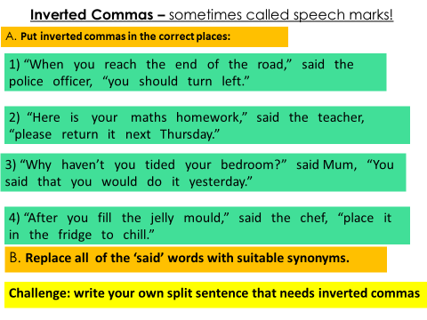

**Maths**

Daily 4 Number Operations answers:

|  |  |  |  |  |
| --- | --- | --- | --- | --- |
| 1. 99,653 2. 53,701 3. 8642 4. 3680 5. 1380 6. 10,395 7. 2332 8. 524 | 1. 109,999 2. 146485 3. 5100 4. 4842 5. 1888 6. 12,489 7. 4231 8. 147 | 1. 79,898 2. 195,016 3. 22,222 4. 77,690 5. 3265 6. 24,570 7. 2121 8. 252 | 1. 98,759 2. 98976 3. 53,512 4. 88,412 5. 5988 6. 19,432 7. 4321 8. 528 | 1. 99,989 2. 122,108 3. 40,400 4. 47,109 5. 1780 6. 6,516 7. 3223 8. 174 |

Daily Arithmetic Answers:

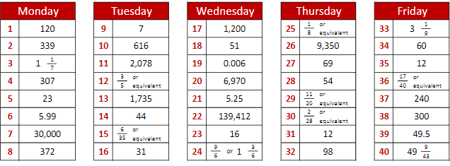

*Please note that the maths investigations are open ended answers.