**Home Learning**

**Year 2 – Term 5 Week 2-Week beginning 27th April 2020**

**Reading:**

Try and read a few pages every day.

Over the week:

* Look at the front cover of a book and make a prediction on what you think the book will be about. Think about where the story might be set, the characters you think may be involved in the story and what you think will happen. Use the following sentence stems: **I wonder if…., I think that…, I imagine……, I predict… because…**
* As you are reading your book, ask the person you are reading to to ask you some questions about the book (using sentences beginning with **who, what, when, where, why & how).**
* Once you have read your story, tell an adult about what you have read.

Think about the key points or events that happened within your story and include these in your summary.

* Have a go at the Sound Keeper poem reading comprehension.

**English:**

Mon: Look at the powerpoint. Use adjectives to describe the pictures. Read ‘The magic seashell’.

Describe a scene using your senses. Use adjectives, similes, exciting verbs, adverbs.

Tue: Write your own ‘magic seashell’ poem, using your senses. Follow the pattern of the poem. (See the poem given in the powerpoint for an example, follow the pattern of this poem. Use the writing frame- seaside senses poetry- if you want).

Wed: Read ‘The Sound Collector’ poem. Pick out all the different sounds that are in the poem. Fill in the table , with sounds and objects from the poem (see WALT plan a sound poem sheet)

Thur: Make up your own ‘sound collector’ poem. You could do it for sounds at home, or you could do one for school or on a holiday. Fill in the table (using the same format as yesterday). Remember you can magpie words and phrases from poems you have read before. Then use this to write your own poem.

Fri: Choose either your magic seashell poem or your sound collector poem (or both if you want!) and write it out in your best handwriting with all spellings corrected. Illustrate it. If possible, please send your poems into school so that we can make them up into a Year Two poetry book. (You can also send in the poem you chose to copy into best from last week as well.)

Phonics/ Spellings- This week we are looking at words that make the –le sound ending, but they are spelt a different way which is more unusual ( –al and –el words). Learn the spellings in your group list. Have your test at home on Friday.

**Maths-**

* **Go to** [**www.whiterosemaths.com/homelearning/**](http://www.whiterosemaths.com/homelearning/)

**Click on Year 2, week 2. Watch the video, try the questions-watch out, the more you do, the harder they get!**

* 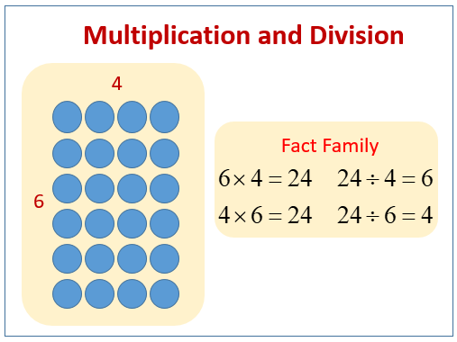Practice multiplication and division.

**Monday-**write out your 2x,5x and 10x tables as quickly as you can. Challenge yourself with a new times table to learn (3x and 4x or 6x, 7x, 8x….) What patterns can you spot in the answers?

**Tuesday-**Multiplication practice and word problems worksheet

**Wednesday**-Pick any number between 5 and 50. Can you divide it by 2? 5? 10? If it can’t be divided into EQUAL groups, what is left over is called the **remainder.** So 17 *÷ 5 =* 3 remainder (r) 2

Repeat for other random numbers. **Challenge- have a go at dividing by the new times table you practised on Monday.**

**Thursday**-Division problem solving worksheet

**Friday-** X factor tables test- Choose the best test for you. How many answers can you get right in 10 minutes? Look at any that you got wrong, practise them and then have another go.

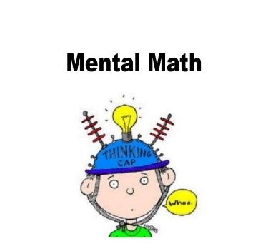**Mental Maths**

Superfast times tables questions with some division questions thrown in too!

Halve even numbers up to 40 (and then go beyond 40)

Tell the time –Look at the time when it is 5 past, 10 past, 20 past and 25 past the hour

**Don’t forget you can log in to Professor Assessor and we will be able to see your results!** [**https://www.prof123.co.uk/**](https://www.prof123.co.uk/)

**History:** Continue with your diary that you started last week.

**Geography-** Find some squared paper (I’ve attached a sheet) and put a cross in the middle square. Sit down in the centre of your living room or garden and listen out for all the sounds you can hear. Mark yourself in the middle of the sound map. Stay still for a short while (try 5 minutes) and start to listen to what is making sounds around you. Mark on the paper the sounds you can hear and where they are coming from, for example, birds singing above and a car to the west of you, or a kettle boiling in the kitchen, someone sneezing. Be still and quiet and really focus on sounds you can hear.

Are they North, South, East or West of you? You would need to know if you are facing North, South, East or West. Mark them on your map. Add on some of the things that you can see as well. If you’re making a sense map, you could include different smells as well…

**PSHE/Acts of kindness :** Draw around your hand on a piece of paper, in each outline of a finger write one thing you are thankful for. For example: family, friends or the environment. Cut it out carefully and stick on another piece of paper. You could add a rainbow onto the background.

**RE:** Look at the different symbols connected with Easter. Make a collage (draw a picture) called Symbols of Easter. Explain the meaning of a least two symbols. Extension: Record the meaning of the symbols in sentences. Talk about (at a simple level): Why is the Easter story important for Christians? Look at the Easter Art pictures – what do you see? What do they make you think of?

**Art** :Paint of picture or make a collage that shows the sounds that you heard when you were doing your geography. If you’re making a collage, can you make a furry bee that’s buzzing and some crinkly leaves blowing in the wind? What other textures can you use in a collage? Take a photo of your painting or collage and send it to [Sarah.Taylor@st-patricks.wilts.sch.uk](mailto:Sarah.Taylor@st-patricks.wilts.sch.uk) who will be able to forward it to us.

**PE**

Visit *The Body Coach* TV YouTube channel each morning at 9am as he will be providing a live PE at home lesson. <https://www.youtube.com/channel/UCAxW1XT0iEJo0TYlRfn6rYQ>

Go for a cycle ride or out on your scooter as part of your daily exercise.

**Mindfulness**

* Need a time out? Go online to Cosmic Kids Yoga and follow a guided relaxation video @<https://www.youtube.com/user/CosmicKidsYoga>

**Useful Websites:**

<https://www.topmarks.co.uk/>- Maths and English interactive activities

<https://www.nhs.uk/change4life/recipes>- Cooking Ideas

<https://www.bbc.co.uk/bitesize/dailylessons>- Daily lessons for each year group