1. I have £39. I spend £14. How much do I have now? £25

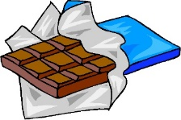

1. Patrick bought 23 choc bars and his sister bought 24. How many did they have altogether? 47

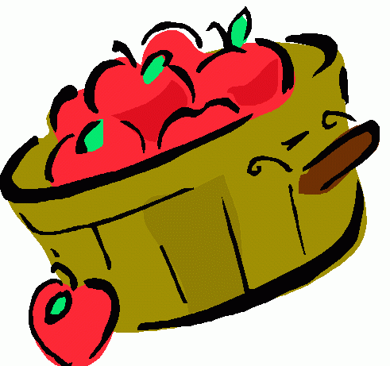

1. There were 79 apples in a barrel, 43 went bad. How many were still good? 36
2. John prints off 57 pages on his computer. 32 are in colour. How many in black and white? 25

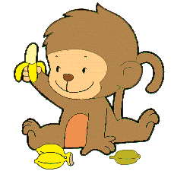

1. The monkeys in the zoo ate 42 bananas on Saturday and 26 more on Sunday. How many did they eat on Sunday? 68
2. Mr Taylor is 95 years old. His wife is 73. How much older is he? 22 years

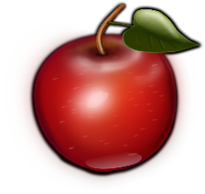

1. There were 48 apples on my tree but 25 have fallen off. How many are left? 23

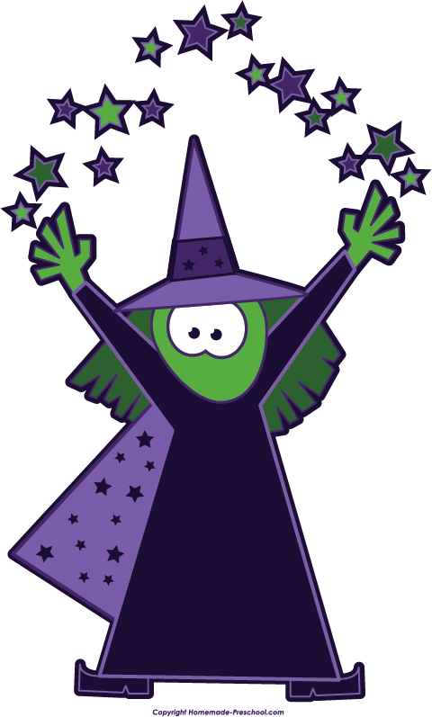

I planted 98 pumpkin seeds but the birds ate 89. How many seeds do I have left? 9 *C*

1. If I have 80p and want to buy a lolly for 30p and a drink for 40p. Will I have enough money? Yes

10. How many subtraction sums can you write that have the answer 25? Challenge yourself with bigger numbers.

Eg 30-5=25 28-3 =25 50 – 25 = 25 99 – 74 =

Start at 60 and count back in 5s:

60 55 50 45 40 35 30 25 20 15 10 5 0

Start at 92 and count back in 10s:

92 82 72 62 52 42 32 22 12 2

Start at 42 and count back in 2s:

42 40 38 36 34 32 30 28 26 24 22 …….