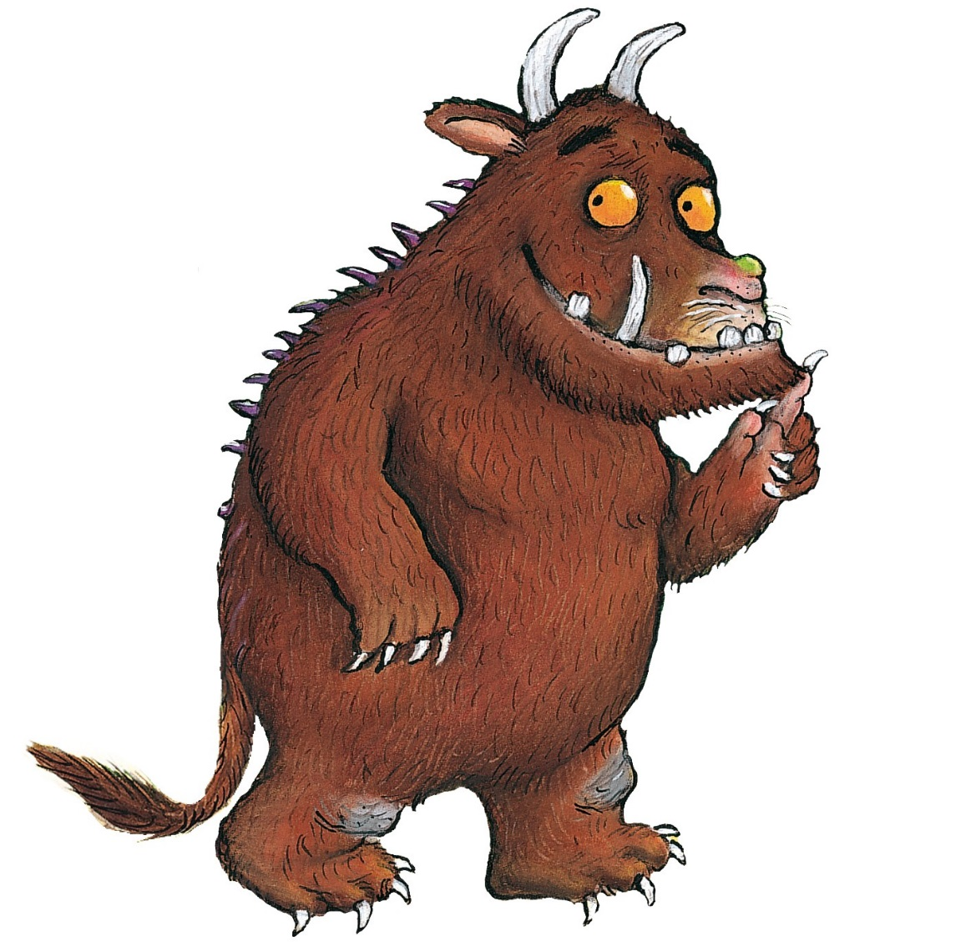
The Gruffalo
The Gruffalo has two large, curved horns at the top of his head. He has bright orange eyes and a slimy, black tongue. The Gruffalo has an enormous, poisonous wart on the end of his wet nose. Running all down his back are sharp pointed prickles. His claws are as sharp as razors but his teeth are blunt and brittle. His fur feels as soft as a cotton wool but it is matted and tangled. He has knobbly knees and turned out toes. His feet are gigantic and he stomps through the forest whilst swishing his long bushy tail. The animals are scared of him because he is so terrifyingly large.

