**Home Learning**

**Year 2 – Term 6 Week 2-Week beginning 8thJune 2020**

**Reading:**

Try and read a few pages every day.

Over the week:

* Look at the front cover of a book and make a prediction on what you think the book will be about. Think about where the story might be set, the characters you think may be involved in the story and what you think will happen. Use the following sentence stems: **I wonder if…., I think that…, I imagine……, I predict… because…**
* As you are reading your book, ask the person you are reading to to ask you some questions about the book (using sentences beginning with **who, what, when, where, why & how).**
* Once you have read your story, tell an adult about what you have read.

Think about the key points or events that happened within your story and include these in your summary.

Read ‘Treasures of the Deep’ which has been written for World Oceans Day with your parent or older sibling. Discuss the themes in the book. Can you remember what you found out about recycling/reusing/reducing in ‘Our Common Home’ week?

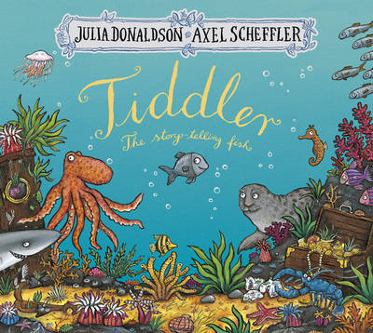

**English:**

Read ‘Tiddler’. Who is the author? TALKING: find someone in your family or speak to one of your friends (with your parents’ permission). What do you notice about the book? What are the main events in the book? What do you like? Is there anything you don’t like? Which book did you prefer: Tiddler or The Gruffalo? Why? What are the similarities? What are the differences?

***Compare books by the same author***: Write sentences about the book, remembering to use capital letters and full stops in the right places. *What are the main events in the book? What do you like? Is there anything you don’t like? Which book did you prefer: Tiddler or The Gruffalo? Why? What are the similarities? What are the differences?*

What sea creatures are in the book? Make a list. Use the internet and non-fiction books to find information and facts about some of the sea creatures featured in the story. You could use a site such as: [www.a-z-animals.com/animals/pictures/](http://www.a-z-animals.com/animals/pictures/) to gather information.

Create a fact file for one of the sea creatures. You can use the sheet ‘My Fact File’ or create your own. Remember to add illustrations.

Choose some common word spellings that you need to practise. Write the words in sentences, remembering to use capital letters and full stops in the correct places.

Phonics/ Spellings- How did you get on with your spelling test last week? Are there any words you need to go back to practise? This week we are looking at the spellings for months of the year. Please keep practising some common word spellings as well. Learn the spellings in your group list. Have your test at home at the end of the week after you have practised your spellings a few times.

Group One

1. January
2. February
3. March
4. April
5. May
6. June
7. July
8. August
9. September
10. October
11. November
12. December

Group Two

1. March
2. April
3. May
4. June
5. July
6. October
7. November
8. December
9. year
10. month

Group Three

1. of
2. that
3. the
4. then
5. to
6. was
7. went
8. with
9. my
10. and

**Maths- For the next 2 weeks, we’re following the white Rose Unit on Fractions**

* **Go to** [**www.whiterosemaths.com/homelearning/**](http://www.whiterosemaths.com/homelearning/) **Click on Year 2, week 7 .** Watch the video, complete the daily worksheets in our Home Learning folder-there are 4 days of fraction work this week.
* **Practise – Adding and subtracting Tens and Units**
* **Monday**  - addition with support worksheet
* **Tuesday -**addition of TU
* **Wednesday** – subtraction with support
* **Thursday –** subtraction of TU
* **Friday-** We likeSnappy Maths for practising important processes. <http://www.snappymaths.com/> Look on the Year 2 addition and subtraction pages and practise anything that you’ve found tricky.

**Don’t forget you can log in to Professor Assessor and we will be able to see your results!** [**https://www.prof123.co.uk/**](https://www.prof123.co.uk/)

If you would like to know your login details again, do let us know.

**Science:** Monday 8th June is World Oceans Day. What can you find out about the oceans? You found out about Rainforests last term; Oceans are another type of habitat-they are Tiddler’s habitat! Look at the Powerpoint and the fact sheets about habitats; write some facts about the ocean habitat.

**Geography :** Monday 8th June is World Oceans Day. Use an atlas to find all the oceans in the world. How many are there? What are they called? If you travelled from the UK to Africa, which ocean would you fly over? What about if you flew to America? Or Australia?

**RE:** Can you draw your own Pentecost picture, using images (eg flames, wind, dove) and colours (eg red/yellow/ orange) that link with Pentecost? Extension: write some sentences to explain why you chose the images/colours that you did.

**ICT:** Keep practising your keyboard skis on[**https://www.dancemattypingguide.com/**](https://www.dancemattypingguide.com/)

In Year 2, we have started computer programming using Scratch **https://scratch.mit.edu/** and  **https://www.scratchjr.org/** They have lots of different projects which appeal to year 2 children, building an understanding of algorithms , creating stories and animations and learning about the world of coding.

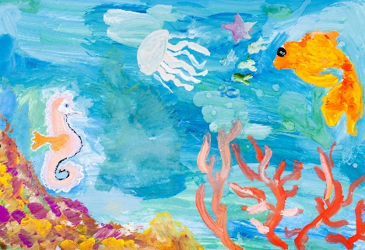**Art :** Can you paint an underwater picture and create your own fish to swim through the seaweed? You could add tissue paper or sea coloured fabrics to add to the watery feel. Paint the sea in a wavy, swirly way to show the movement of the water. Use different shades of blue and green too.

**PSHE/Acts of kindness :**

Write a message of kindness to your future self. Think about where you hope to be next year or many years in the future. Write yourself a kind message about this time at home. Think about all the positive things.

What do you think will change? Think of 3 positive things to say to yourself that you hope you always remember about this time.

Reflect on why kind messages are important.

**PE:**

Visit *The Body Coach* TV YouTube channel each morning at 9am as he will be providing a live PE at home lesson. <https://www.youtube.com/channel/UCAxW1XT0iEJo0TYlRfn6rYQ>

**OR**

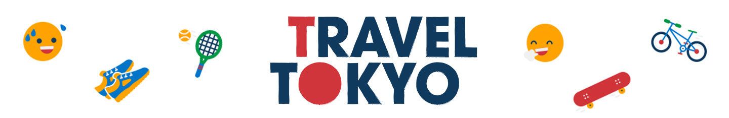Play the Tokyo Ten Be Boulder game, linked with the Get Set for Tokyo resources.

**Useful Websites:**

<https://www.topmarks.co.uk/>- Maths and English interactive activities

<https://www.nhs.uk/change4life/recipes>- Cooking Ideas

<https://www.bbc.co.uk/bitesize/dailylessons>- Daily lessons for each year group. The maths fits in with White Rose Maths too <https://www.thenational.academy/>3 hours of online lessons daily.