**Home Learning**

**Year 2 – Term 6 Week 4-Week beginning 22nd June 2020**

**Reading:**

Try and read a few pages every day.

Over the week:

* Look at the front cover of a book and make a prediction on what you think the book will be about. Think about where the story might be set, the characters you think may be involved in the story and what you think will happen. Use the following sentence stems: **I wonder if…., I think that…, I imagine……, I predict… because…**
* As you are reading your book, ask the person you are reading to to ask you some questions about the book (using sentences beginning with **who, what, when, where, why & how).**
* Once you have read your story, tell an adult about what you have read.

Think about the key points or events that happened within your story and include these in your summary.

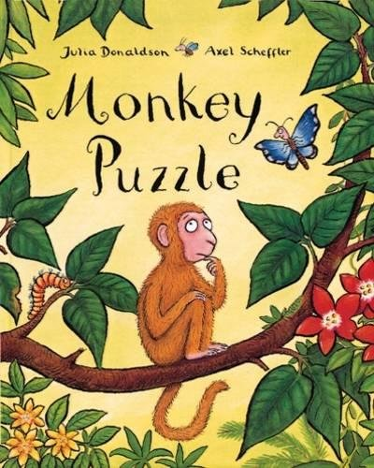***This is our final week looking at Julia Donaldson books, so continue to read and enjoy them! You could also find out more about the author herself by reading information on the official Julia Donaldson website:*** [***www.juliadonaldson.co.uk***](http://www.juliadonaldson.co.uk)

**English:**

Read ‘Monkey Puzzle’. Who is the author? TALKING: *What do you notice about the book? What are the main events in the book? What do you like? Is there anything you don’t like? Which book did you prefer: The Snail and the Whale or Monkey Puzzle? Why? What are the similarities? What are the differences?*

Write sentences about the book, remembering to use capital letters and full stops in the right places. What are the main events in the book? What do you like? Is there anything you don’t like? Which book did you prefer: The Snail and the Whale or Monkey Puzzle? Why? What are the similarities? What are the differences?

Write your own riddles! Think of some clues that will let the reader work out what the answer is by they end. Write four or five ‘clue’ sentences and then finish with the answer in a sentence. For example:

What has…

It has…

It can…

You can use it to…

It is …. !

Book review: write a book review for one of the Julia Donaldson books. It can be one we’ve looked at over the last few weeks, or a different one that you have read. Who would you recommend your book to and why? If you want to, you could write book reviews for other books you haver read too.

Handwriting: copy out a favourite section of a Julia Donaldson book in your best handwriting, trying to join your letters up if you can. You could add an illustration too.

**Practise your spellings.** How did you get on with your spelling test last week? Which words do you need to go back and practise again?This week we are looking at common spellings.Can you use them in sentences, using capital letters and full stops? Some of these words will be useful in your English sentences this week. Look at the 100 common exception word list and see which ones you need to learn. Practise the ones that you need to learn. Remember to have your spelling test on Friday.

Group One

1. colourful
2. orange
3. purple
4. rainbow
5. bright
6. square
7. circle
8. triangle
9. rectangle
10. octagon

Group Two

1. because
2. children
3. every
4. pretty
5. beautiful
6. many
7. people
8. half
9. busy
10. everybody

Group Three

1. one
2. very
3. every
4. everyone
5. old
6. cold
7. told
8. hold
9. gold
10. fold

**Maths- Problem Solving and Reasoning-SATS type questions**

* **Monday**  - Read through the first few questions in the **S**ecrets **A**gents **T**ask**s** booklet with an adult. Chat about how you would solve the problem. Then work out your own answers independently, showing all your working out. Check the answers with an adult.
* **Tuesday -** Finish questions in the booklet-talking them though before and after you’ve worked

out the answer.

* **Wednesday** – Look through the White Rose Hub Reasoning and Problem Solving Questions sheets on screen. Work out some answers in your workbook-no need to print the problems out!
* **Thursday –** Try a SATS Arithmetic paper (No need to do more than 40 minutes)
* **Friday-** Try a SATS Reasoning paper (No need to do more than 40 minutes) Apologies-I no longer have the oral questions to ask at the beginning of this paper!

**Don’t forget you can log in to Professor Assessor and we will be able to see your results!** [**https://www.prof123.co.uk/**](https://www.prof123.co.uk/)

**Science: Life cycles** Can you draw the life cycle for a butterfly, like the butterfly in our story this week? Can you draw the lifecycle of a frog? Can you draw the life cycle for a human? How about for a plant? Look at the Plant Lifecycle powerpoint. Look on BBC Bitesize KS1 Science for more information. Watch the videos. Have a go at the quizzes!

**ICT:** Keep practising your keyboard skills on[**https://www.dancemattypingguide.com/**](https://www.dancemattypingguide.com/)

Another sort of dancing is something that you can practise on the coding website www.code.org Click on the create button and then watch the video about **Dance Party.** I choreographed a dance for a sloth (yes, really!) to one of our favourite dance tracks (Katie Perry’s Firework)-it was great fun!

**PSHE/Acts of kindness :** The values of the Olympic games are very important and link to our everyday lives too. Have a look at the linked activities in the ‘Get the Values’ Tokyo resource about determination, courage, inspiration and respect. You could make the bookmark or the rosestte or the Olympic torch.

**RE:** Miracles What do you think a miracle is?

In the Bible, the Gospel writers describe many miracles that Jesus performed. A miracle isn’t ‘magic’. Magicians use tricks to shock and entertain an audience; Jesus performed miracles which revealed meanings about God’s love for us and the way we should live.

https://www.youtube.com/watch?v=ZzPwRXytr7U

The Calming of the Storm

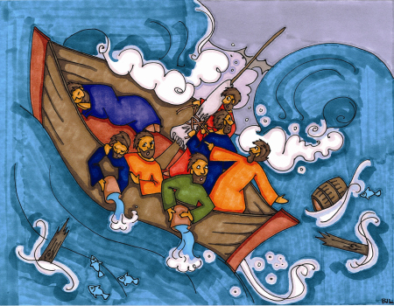After he had spent a day teaching people, Jesus wanted to get away from the crowds for a while so he said to his disciples, “Let’s go to the other side of the Lake for a bit.”

The disciples followed Jesus into a boat to cross the Sea of Galilee. Can you name any of the disciples?

Now Peter, Andrew, James and John were fishermen and they knew that Lake Galilee could be dangerous with bad storms coming up very quickly. However they set sail. Jesus, exhausted from the crowds, falls asleep with his head on a pillow.

Suddenly dark clouds appeared on the horizon. The wind picked up; waves slapped against the hull of the boat. The disciples in the driving rain took the sail down, but this storm was really bad. Waves spilled over and threatened to swamp the boat. Chilled to the bone, the disciples bailed water as fast as they can. They began to panic - Jesus was still asleep. The disciples grabbed Jesus and shook him. “Master, save us. Don’t you care if we drown?”

Jesus woke up, took stock of the situation, and looked at them. The disciples read his face: he wasn’t afraid, but he wasn’t happy either! He stood up, turned to face the waves and said, “Calm down! Be still!” Immediately there was a great calm. The waters were still. Then he turned to the disciples and said, “Why are you afraid? Don’t you have any faith?”

The disciples were afraid and they turned to each other and said, “Who is this man? Even the wind and waves obey him!”

Questions: What questions do you have about the story? Who needed help in this story and why? What does Jesus do? Why do you think he asks the disciples if they have any faith? Did they trust Jesus? How do you think they felt when the storm started? How do you thing they felt when they saw that Jesus was able to stop the storm? What do you think the story teaches us?

Can you draw a cartoon strip to show the main events of this story?

Can you find out about a different miracle Jesus performed and talk about its meaning with an adult?

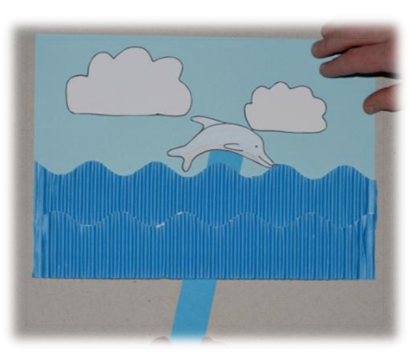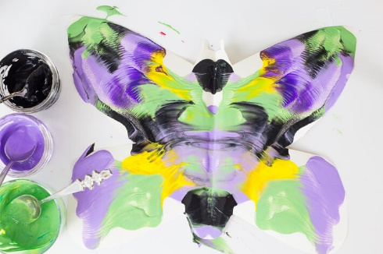**Art** : Butterflies are beautifully symmetrical. Create your own symmetrical butterfly by folding a piece of paper in half and painting HALF a colourful butterfly in poster paints on one side of the piece of paper. Don’t forget the wings, body, head and antennae. You can use lots of different colours. Fold the other side over the painted side and press down. When you open it up again you should find a symmetrical butterfly. You could cut it out and stick on anything you like-just remember to keep it symmetrical!

**DT:** If you enjoyed making the moving card with sliders last week, try making a card where the moving part is lifted by a lever. Look at the PowerPoint for ideas. You could make the dolphin, or perhaps try a jumping frog to fit in with this week’s science. Who could you send your card to?

**Music:** We’re very sad not to be able to be teaching you how to play the recorder this term. Perhaps you’d like to learn online? There are lots of different lessons on Youtube; I quite liked this teacher:

<https://www.youtube.com/watch?v=em6adp0bwAg&list=PLuF_UlmBJIShMDTfZdEjBgYoYNdS6OZHj&index=6>

You can buy an AULOS recorder online for between £7 and £8 and that would be fine for learning. Good luck!

**PE:**

Visit *The Body Coach* TV YouTube channel each morning at 9am as he will be providing a live PE at home lesson. <https://www.youtube.com/channel/UCAxW1XT0iEJo0TYlRfn6rYQ>

**Don’t forget Joe is in need of a rest so will only be taking classes on Mondays, Wednesdays and Fridays.**

**OR**



Try the Tokyo 10 House Workout!

**Useful Websites:**

<https://www.bbc.co.uk/bitesize/dailylessons>- Daily lessons for each year group. The maths fits in with White Rose Maths too <https://www.thenational.academy/>3 hours of online lessons daily.