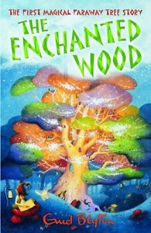**Book Review by Abby Dunn**

**The Enchanted Wood by Enid Blyton**

The story is about three children that have moved from a city to the countryside. They find they live near a wood and go and explore it. They find a big tree in the middle of the wood and at the top of it there are different lands to visit, some are good and some are bad!

The book is full of the adventures the children have.

The main characters are Beth, Frannie and Joe. They are brother and sisters and are very good, they help their mum and dad by doing chores. They like to explore the big tree, called the Faraway Tree and meet their friends Moon-Face, Silky and Saucepan Man.

I would like Beth, Frannie and Joe as my friends because they are fun and kind and have lots of ideas.

The things I liked about the book were finding out which land they were going to next and whether it was good or bad. I also liked meeting the characters that lived in the tree, Silky and Moon-Face were my favourites.

Moon-Face is my favourite character, he is kind and lives at the top of the tree. He has a slide called the slippery-slip which goes from his house to the bottom of the tree and they side down on a cushion and land on a pile of soft moss at the bottom through a trap door. He likes toffee and has Toffee Shocks which gets bigger and bigger as you chew it and then explode in your mouth and then it disappears.

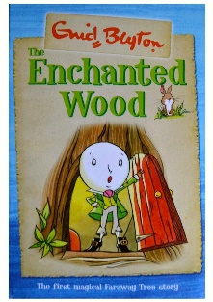My favourite part is where they visit the Land of Birthdays for Beth’s birthday, you can only visit when it’s your birthday or when you’ve been invited. You get dress up, play games and have a birthday lunch. Beth got wish what there was to eat. There is a special cake that gives wishes. I like it because they give you presents, there are games to play and you can wish what you want.

The book shows how sticking together with your friends can help you out.

The book is full of adventure with funny bits in it too.