

**KS2**

Dear Parents and Carers,

This home learning resource brings together a range of free and easy to access online activities and learning for children in KS2 and is clearly grouped into subjects and topics. We will update this resource weekly and hope it will support you through disrupted schooling.

It is important for your children to experience a range of different activities during the day to support different aspects of their learning and development. The Pick and Mix suggestion contains a wide range of activities to keep them interested. Try to develop a routine for learning with your child which will create a sense of normality in these uncertain times. There is a section on well-being and we strongly recommend you plan at least one session every day of exercise and mindful activity.

**English**

**Words for Life:** <http://www.wordsforlife.org.uk/>

Advice for parents and carers on how to help their children read and become bookworms!

David Walliams Activities: [**https://www.worldofdavidwalliams.com/activities/**](https://www.worldofdavidwalliams.com/activities/)

Lots of free activities, games and quizzes all linked to his books.

Elevenses with the World of David Walliams: [**https://www.worldofdavidwalliams.com/elevenses/**](https://www.worldofdavidwalliams.com/elevenses/)

Free audio reading of one of his books at 11am every day for the next 30 days.

Last for about 15-20 mins.

Free Kindle Editions:

Treasure Island: [**https://www.amazon.co.uk/Treasure-Island-AmazonClassics-Robert-Stevenson-ebook/dp/B072Q1KBRT/ref=sr_1_1?keywords=Treasure+Island+kindle&qid=1583171104&s=digital-text&sr=1-1**](https://www.amazon.co.uk/Treasure-Island-AmazonClassics-Robert-Stevenson-ebook/dp/B072Q1KBRT/ref=sr_1_1?keywords=Treasure+Island+kindle&qid=1583171104&s=digital-text&sr=1-1)

Alice’s Adventures in Wonderland: <https://www.amazon.co.uk/Treasure-Island-AmazonClassics-Robert-Stevenson-ebook/dp/B072Q1KBRT/ref=sr_1_1?keywords=Treasure+Island+kindle&qid=1583171104&s=digital-text&sr=1-1>

Picture Book Maker:

[**https://www.culturestreet.org.uk/activities/picturebookmaker/index.php?id=3**](https://www.culturestreet.org.uk/activities/picturebookmaker/index.php?id=3)

Create your own picture books with the help of this online tool. You choose the setting, the characters and write the story. Share your finished picture book in Culture Street’s online gallery.

Literacy Shed

<https://www.literacyshed.com/home.html>

Short clips organised into themes most come with suggestions for writing ideas, comprehension questions and wider learning opportunities.

**Maths**

**The Maths Factor:** <https://www.themathsfactor.com/>

Carol Vorderman has announced that access to her maths school The Maths Factor will be free while schools are closed (normally £2/week). It's aimed at 4 to 11-year-olds and is matched to the national curriculum.

<https://buzzardpublishing.com/product/candomaths-workouts-parentpacks/>

Can Do Maths packs specifically to support parents along with video links <https://www.youtube.com/channel/UCtamY3wAjj85YpH5Zv4CTBQ/videos>

Corbett Maths [**https://corbettmaths.com/**](https://corbettmaths.com/)

Videos, quizzes and ‘5 a day’ to keep skills sharp

**Science and Technology**

STEM: [**https://www.stem.org.uk/home-learning/primary**](https://www.stem.org.uk/home-learning/primary)

Starters for STEM are ten activities that parents can use at home to help children develop their science, technology, engineering and maths skills. These activities are easy-to-resource and provide children with the stimulus to talk about the world around them.

Scratch <https://scratch.mit.edu/>

Great site for children to practise coding and programming skills

Learn to touch type! <http://www.typingclub.com/sportal/program-3.game>

A programme to help children learn to touch type.

**Playful and Creative Activities**

Fender Play: [**https://try.fender.com/play/playthrough/**](https://try.fender.com/play/playthrough/)

Three months of free guitar lessons

**Rosetta Stone:** <https://www.rosettastone.com/freeforstudents/>

Free three-month subscription to learn one of 20 different languages

TateKids: [**https://www.tate.org.uk/kids**](https://www.tate.org.uk/kids)

Play free art games and fun quizzes, find art activities, read about artists and share your art.

Tate Paint: [**https://www.tate.org.uk/kids/games-quizzes/tate-paint**](https://www.tate.org.uk/kids/games-quizzes/tate-paint)

Create your own masterpiece – be creative on your own or let the Tate inspire you with different themes like the weather or food.

The Great Indoors: [**https://www.scouts.org.uk/the-great-indoors/**](https://www.scouts.org.uk/the-great-indoors/)

Whilst the Scouts are usually known for their love of the great outdoors, they have switched to pulling together some inspired indoor activity ideas. Keep your kids learning new skills and having fun (and avoid hearing ‘I’m bored’ every 30 seconds) all in #TheGreatIndoors.

Outdoor Classroom Day <https://outdoorclassroomday.com/>

Outdoor Classroom Day is a celebrates and inspires outdoor learning and play

National Trust 50 things to do… <https://www.nationaltrust.org.uk/50-things-to-do>

Outdoor activities to do all year round, from watching the sunset to creating some wild art.

National Geographic for kids <https://www.natgeokids.com/uk/>

Range of activities over many subject areas.

**Exercise and Wellbeing**

Calm Kids: [**https://www.calm.com/blog/take-a-deep-breath**](https://www.calm.com/blog/take-a-deep-breath)

A whole selection of audible files to help bring calm. Meditation can empower children to feel resilient and strong. Use these meditations and Sleep Stories to bring some peace to the little people in your life.

**Go Noodle:** <https://www.youtube.com/user/GoNoodleGames/videos?disable_polymer=1>

GoNoodle videos get kids moving to be their strongest, bravest, silliest, smartest, best selves! Offers movement, yoga and mindfulness activities.

You can also join the GoNoodle Good Energy at Home <https://www.gonoodle.com/good-energy-at-home-kids-games-and-videos/> which has been specifically designed to support families at this time.

PE with Joe: <https://www.youtube.com/watch?v=Rz0go1pTda8>

Join people all around the world for a daily workout at 9am, or watch later.

Supermovers: [**https://www.bbc.co.uk/teach/supermovers**](https://www.bbc.co.uk/teach/supermovers)

English and Maths learning linked to movement and song as well as a PSHE and Just for Fun section.

Smiling Mind [**https://app.smilingmind.com.au/**](https://app.smilingmind.com.au/)

Meditation. Short audio sessions to help with mindfulness.

**Links to all areas of learning**

Ted Ed <https://ed.ted.com>  
All sorts of engaging educational videos for children to watch

BBC Bitesize targeting KS2 <https://www.bbc.co.uk/bitesize/learn>

Activities for all areas of the curriculum.

**Key Stage 2 Home Learning Pick ‘n’ Mix Activities – Week 3**

To extend your learning, you can choose to complete as many tasks as you like from the options below.

|  |  |  |
| --- | --- | --- |
| **Creative Writing**  resource image  **The Magical Eggs**  See the next page for some creative writing ideas for this fascinating picture. | **Number fun**  Can you solve this Easter puzzle?  Peter, Melanie, Amil and Jack received a total of 38 chocolate eggs.  [This Photo](http://fr.wikipedia.org/wiki/fichier:easter-eggs-1.jpg) by Unknown Author is licensed under [CC BY-SA](https://creativecommons.org/licenses/by-sa/3.0/)  Jack had one less than Peter.  Peter had 5 less than Melanie.  Amil had half as many as Melanie.  Peter had 2 more than Amil.  How many eggs did each person have? | **Mindfulness**  Colouring is a fantastic way to focus the mind. Have a go at some Easter themed mindfulness colouring – see page three for some egg designs. More can be found [here](https://www.muminthemadhouse.com/adult-easter-colouring-pages-intricate-eggs/) or [here.](https://www.crayola.com/free-coloring-pages/holidays/easter-coloring-pages/) |
| **Get Coding**  Can you use [Scratch](https://scratch.mit.edu) to code an Easter themed game or quiz?  [ScratchBoi28 on Scratch](https://www.google.co.uk/url?sa=i&url=https://scratch.mit.edu/users/ScratchBoi28/&psig=AOvVaw3fcuD18VWQl-ePVgkVdeKe&ust=1585673221884000&source=images&cd=vfe&ved=0CAIQjRxqFwoTCJDxipvTwugCFQAAAAAdAAAAABAE)  Have a look at some that [others have created](https://scratch.mit.edu/search/projects?q=easter) to get ideas of your own. | **Ready, Steady, Cook!**  Try some Easter baking. There are loads of recipes to choose from on the [BBC website.](https://www.bbcgoodfood.com/howto/guide/fun-easter-projects-kids)  [Chocolate chip hpt cross buns in a basket](https://www.bbcgoodfood.com/recipes/chocolate-chip-hot-cross-buns)  How about making cute meringue chicks or kneading some Hot Cross Buns? | **Eggcellent Eggsperiment!**  Fizzy chemistry and dying Easter eggs combine in this super fun and easy to do Easter science activity.  [Fizzy Dyed Eggs](https://littlebinsforlittlehands.com/dying-eggs-with-vinegar/) |
| **Get Reading!**  As well as reading regularly, why not test your knowledge in some fun quizzes from [Booktrust.](https://www.booktrust.org.uk/books-and-reading/have-some-fun/quizzes/)  There are also loads of other fun book activities and videos on this site. | **Exercise Challenge**  As well as joining in with [PE with Joe](https://www.youtube.com/playlist?list=PLyCLoPd4VxBvQafyve889qVcPxYEjdSTl) each day, have a go at some of the [Supermovers](https://www.bbc.co.uk/teach/supermovers/ks2-collection/zr4ky9q) videos.  Here are some [great videos](https://www.bbc.co.uk/teach/supermovers/times-table-collection/z4vv6v4) to practise your times tables, while keeping active. | **Easter Origami**    Have a go at origami with some of these [Easter themed ideas](https://www.redtedart.com/easy-easter-origami-for-kids/). |

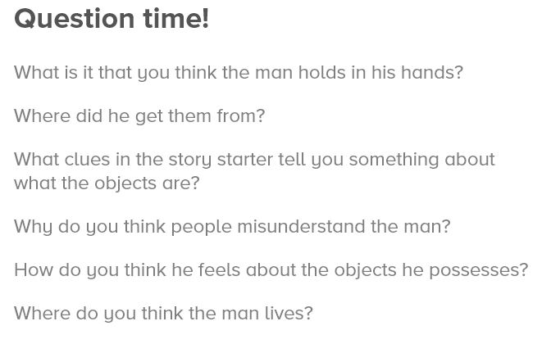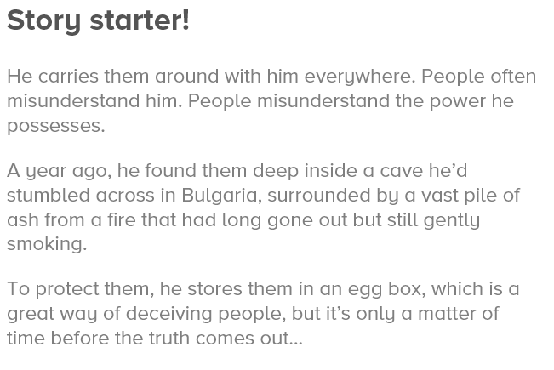**The Magical Eggs**



