KS1 Reasoning & Problem

Solving Questions

# **Reasoning and Problem Solving Questions****Information**

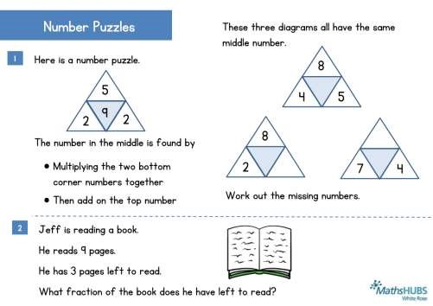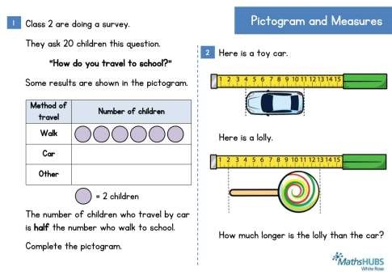

This booklet contains over 40 reasoning and problem solving questions suitable for KS1 classes. These are the questions that we have been putting out each day in March 2016 on Twitter in the run up to SATS.

The answers are provided with some simple notes at the back of the booklet and for some questions supplementary questions and variation has been provided.

|  |
| --- |
| **KS1** |

We hope to release more questions like this over the course of next year including some open ended problems. Please keep a look out for our work. If you have not seen our schemes and assessments for primary then please take a look at our website [www.whiterosemathshub.co.uk](http://www.whiterosemathshub.co.uk/)

As always we welcome any feedback on the work we are doing and the materials that we are releasing.

Thank you for taking an interest in our work.

**The White** **Rose Maths Hub Team**

© Trinity Academy Halifax 2016

For information and comments email mathshub@trinityacademyhalifax.org

**Reasoning and Problem Solving Questions**

# **Children****’s Reponses**

|  |
| --- |
| **KS1** |

Children’s responses will tell you a lot about their depth of understanding of a given topic. For example



**Bar Modelling**

**–**

**Pictorial**

**Methods**

M

any

of the problem solving

questions in this booklet

can

be solved using a bar

modelling

method

. Encour

age

children to use diagrams to

help them solve the probl

em

.

Here is a problem where bar

modelling

would help.

If

you

want to find out more about bar modelling please

contact the Hub.

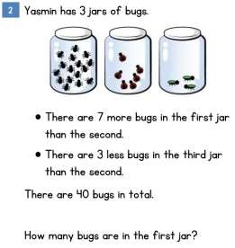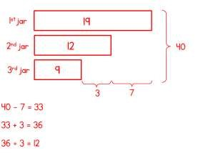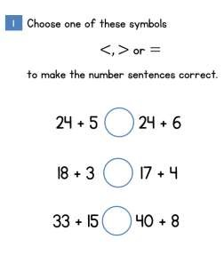

Children who reason verbally or written that 5 is less than 6 and then 24 is being added each time potentially indicate a deeper understanding of number than those who work out both sides of the inequality.

© Trinity Academy Halifax 2016

For information and comments email mathshub@trinityacademyhalifax.org

# Stickers and Squares

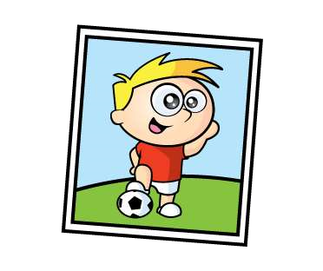 Razza and Gina have the same number of stickers.



2



1

• Razza gives 15 stickers away. • Gina gives 32 stickers away.

How many more stickers than Gina does Razza have now?

Here is part of a number square.

|  |  |  |  |  |
| --- | --- | --- | --- | --- |
| 5 | 6 | 7 | 8 | 9 |
| 15 | 16 | 17 |  |  |
| 25 |  |  |  |  |
|  |  |  |  |  |
|  |  |  |  |  |

Add together the two numbers that would be in the shaded squares.

# Calculations

Choose one of these symbols



1

<, > or = to make the number sentences correct.

24 + 5 24 + 6



 18 + 3 17 + 4



33 + 15 40 + 8



|  |
| --- |
|  |

|  |
| --- |
|  |

Put the numbers 6, 7, 8, 9, 10 and 11 into the boxes. Use each number only once.



2

23 + 10 + > 23 + 10 +



32 + + 5 < 32 + + 5



50 + 30 + = 49 + 29 +



Mary buys

these

two

items.

She pays with the following coin.

Here is the change she is

given

.

Has she been given the correct

change?



1

Presents

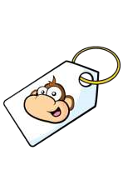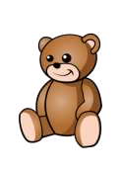

**19**

**pence**

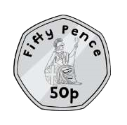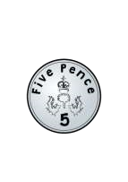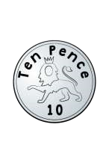

2

Mo buys

a key ring

.

His mum gives him a quarter of the

money.

How much money does he have to pay

himself

?



**1**

**6**

**pence**



**16**

**pence**

# Number Problems



2

Here are some apples.



+

If

+ = 18

Class 2 are asked work out the total.

+ = 18 Here are four different ways they do it.



1

Fill in the missing blanks.

Work out

….. + ….. = 10

+ ….. + ….. + ….. + ….. + ….. = 10

……  …… = 10

……  …… = 10

# Number Problems

Here is a number line. 14



1



2

Here are some digit cards.

Meg

and Sam each use two of the cards to make

a number.

What is the difference between their two

numbers?



I have



I have made the largest

number you can make.



I have made the smallest

number you

can make.



The number 14 is shown. 0

Mark the number 9 on the number line.

# Shopping and Baking

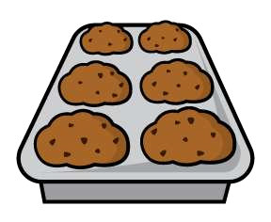



1

Erik

b

akes 5 trays of muffins.

Each tray

contains 6 muffins.

H

e

sells 16

muffins and eats 5

How many muffins does he have left?



2

These items are sold in a shop.

Ray buys three items.

Two of them were the same item.

He spent £23

Which

items d

oes

he buy?

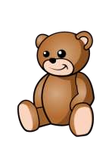

# More Number Problems

Mike buys these items and it costs him 30 pence.



2

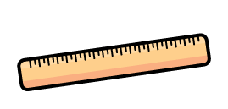

1

Olga buys these items and it costs her 42 pence.

How much does a ruler cost?

Here is a blue strip of paper.

An orange strip of paper is four times as long.

The strips are joined end to end.

|  |  |
| --- | --- |
|  |  |



20

cm

How long is the blue strip?

How long is the orange strip?

# Problems Galore

Each purple block is 8cm long.



1



2

How long is

a

blue block?

Aron has some

balloons

.

Fiona has 12 more

balloons

than Aron.

In total they have 40

balloons.

How many

balloons

has Fiona got?



6

cm

8cm

|  |  |
| --- | --- |
|  |  |

Each green block is 6cm long.

|  |  |  |
| --- | --- | --- |
|  |  |  |

Number Puzzles These three diagrams all have the same middle number.

Here is a number puzzle.

corner numbers together

•

Then add on the top number



2



2



8



7

4



4



8



5

Jeff

is reading a book.

He reads 9 pages.

He has 3 pages left to read.

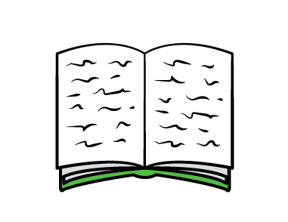

Work out the missing numbers.



2



2



5



9

The number in the middle is found by



1

• Multiplying the two bottom

What fraction of the book does he have left to read?

# Prizes and Balances

Sasha is playing a game to win prizes.

E

ach

blue

counter

is

worth

2

points.

Each

green

counter is

worth

5

points.

She

wins

the following counters.

Which of these prizes can Sasha get?



1



2

Here is a ba

lance

Here is another balance

W

ork out the weight of

two

s

.

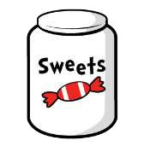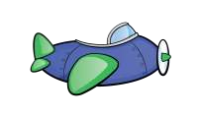

points

50

25

points

30

points

40

points



18

kg



72

kg



# Wednesday Workout

|  |  |  |  |  |  |  |  |  |  |  |  |  |  |  |
| --- | --- | --- | --- | --- | --- | --- | --- | --- | --- | --- | --- | --- | --- | --- |
|  | | 100 | | |  | | | | | 99 | | |  | |
|  | 44 | |  | | |  | | | 44 | |  | | |  |
|  | |  | | 25 | | |  |  | |  | | 25 | | |

In the pyramids the two numbers below add to the make the number above. Complete these two pyramids.



2



25



89



44



1

What is the value of the blue box?

How did you get your answer?

Marie is posting a letter and parcel.

It costs 29 pence to post the letter.

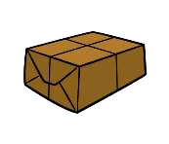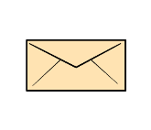

It costs 15 pence more to post the parcel.

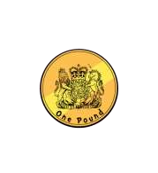Marie pays with this coin.

How much change does she get?

Class 2 are doing a survey.



1

They ask 20 children this question.

“How do you travel to school?”

Some results are shown in the pictogram.

|  |
| --- |
| Pictogram and Measures |

Here is

a toy

car.

Here is a lolly.

How much longer is the lolly than the car?



2

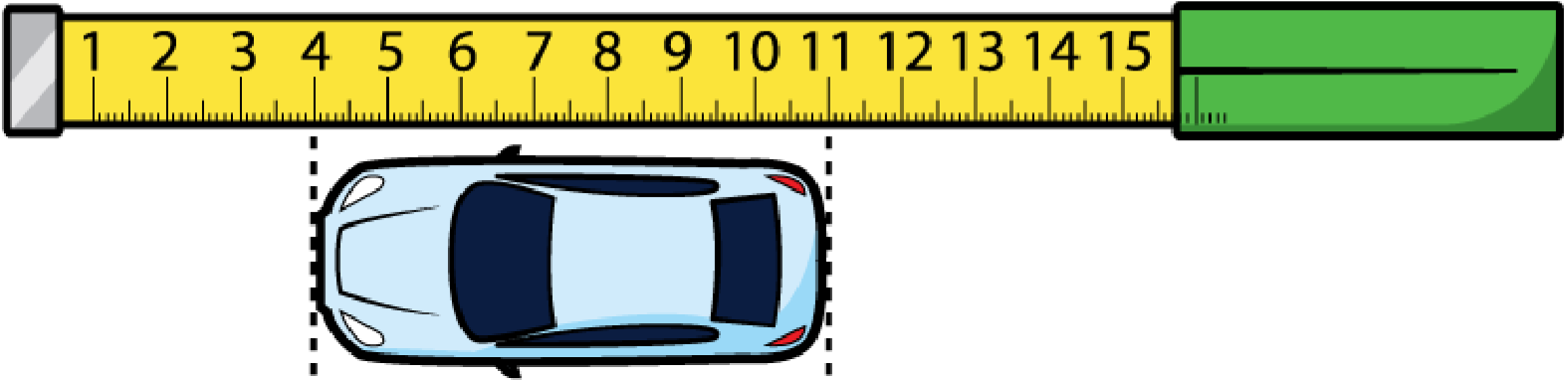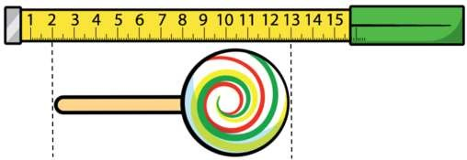

|  |  |
| --- | --- |
| Method of travel | Number of children |
| Walk |  |
| Car |  |
| Other |  |

= 2 children

The number of children who travel by car is half the number who walk to school.

Complete the pictogram.

|  |
| --- |
| For Q2 you might find it helpful to draw a bar model or other diagram. |

# Two wordy problems

Sarah has some 10 pence and 5 pence coins.

She has five 10 pence coins.

Sarah has 85 pence in total.

How many 5 pence coins does she have?

Yasmin has 3 jars of bugs.

•

There are

7

more bugs in the first jar

than the second.

•

There are 3 less bugs in the third jar

than the second.

There are 40 bugs in total.

How many bugs are in the first jar?



1



2

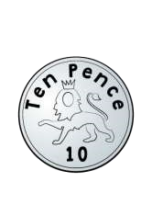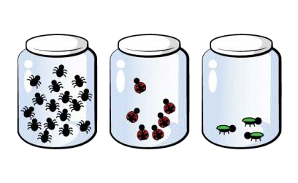

# Number Problems

Mr Drake needs 20 metres of ribbon.



2

Sam

and Zoe

are working out some

subtractions

.

Sam’s answer is double

Zoe

’s answer.



1

I am working

out 74

–

56

One of the numbers

in my questions is 15



Sam

Zoe



Red ribbon costs £5 per metre.

.

Green ribbon costs £2 per metre.

He buys 12 metres of red ribbon. The rest is green.

How much does he spend in total?

What could Zoe’s question be?

# Shopping and Football

Mika buys a bottle of water and a cheesecake.

62

people are going

to

a football game.

They can travel in a

bus or car.

•

A car can hold 5 people.

•

A bus can hold 15 people.

They

plan to

use 6 cars and 2 buses.

Can they all travel to

the game?



2

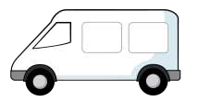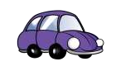

He

pays with the following coins.

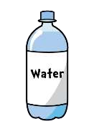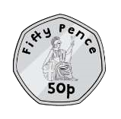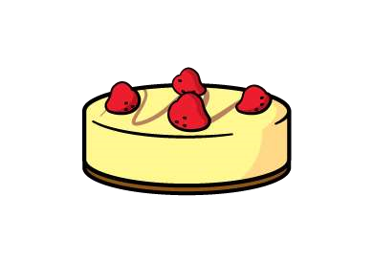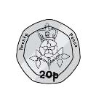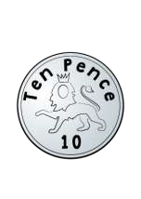

1

He receives 18 pence change.

The water costs 29 pence.

How much does the cheesecake cost?

# Number Problems

Des has some oranges.



2

He packs them into boxes.

Each box holds 5 oranges.

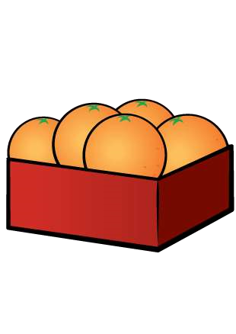

He fills 7 boxes.

He has 29 oranges left.

How many oranges does he have in total?



1

Complete the number sentences.

|  |
| --- |
|  |

5 + 5 + 5 + 5 + 5 + 5 =  5

|  |
| --- |
|  |

10 + 5 + 5 + 5 + 5 =  5

|  |
| --- |
|  |

10 + 10 + 2 + 2 =  2

4 x 2 + 5 x 2 =  2

Explain your methods.

# Number Problems

Here are two number lines.

Find the difference between A and B.



1



2

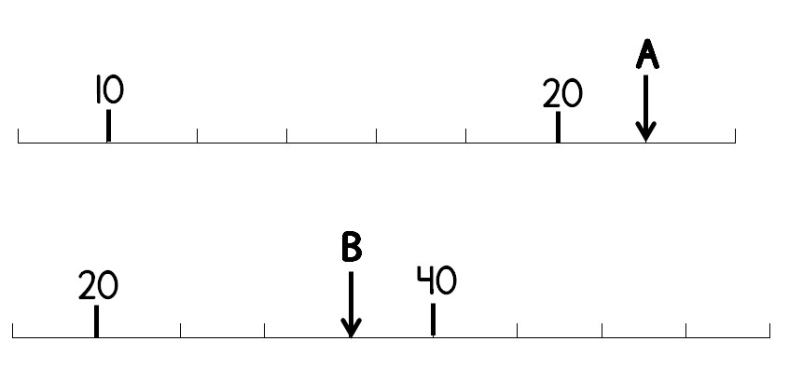

In this diagram shapes represent numbers.

The sum of each row is shown at the side.

Find the value of each shape.

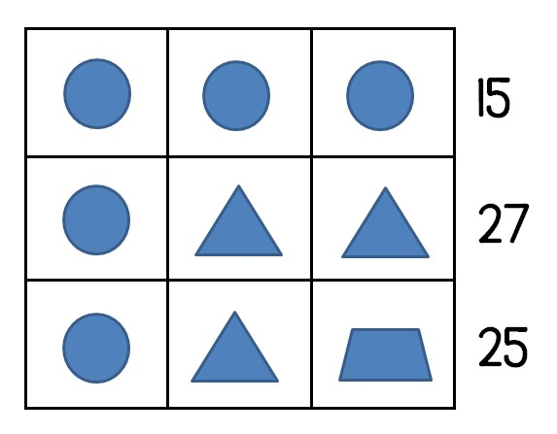

# Number Problems

|  |
| --- |
|  |

|  |
| --- |
|  |

Here is a number sentence. 3 Here is a number line.



4

5 × > 32

What is the smallest whole number that can be used to make the sentence

Mark the number 1 on the line. correct?



1



2



1

4



0



1

2



0

Here is a different number line.

Here is another number sentence.

26 + 15 < 60 −

What is the greatest whole number that can be used to make the sentence Mark the number 1 on this line. correct?

Breakfast Time A TV show starts at this time.



2

One egg and one slice of toast costs 74 pence.

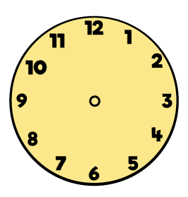

One egg and two slices

of toast cost

s

£1

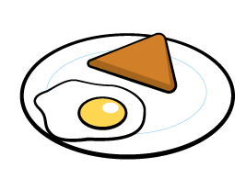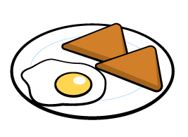

The TV show lasts 45 minutes.

Maria looks at the clock during the show.



1

How much does an egg cost?

How many more minutes does the TV show last?

# Number Problems

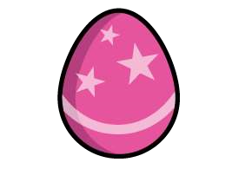



1

Emma has

8

Easter eggs.

7

She has some baskets to fill.

She

fills

each

basket with

10

eggs

.

How many

baskets did she fill?

How many eggs did she have left?

If each basket held only 5 eggs, how

would your answers change?



2

Jo

e

has

t

hese coins.

Balloons

cost 5 pence each.

H

e

buys the following balloons.

How much money does he have left?

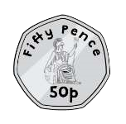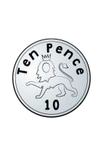

|  |  |  |
| --- | --- | --- |
| **Sheet** | **Answer** | **Notes** |
| **Stickers and squares** | **17** |  |
| **76** | **Encourage students to try to answer the problem without filling in all the squares.** |
| **Calculations** | **<, =, =** | **Encourage students to explain their reasoning without working out each individual calculation.** |
| **11, 10**  **7, 9**  **6, 8** | **Students should start with the last calculation.**  **Various answers available.** |
| **Presents** | **Yes** | **With working** |
| **12 pence** |  |
| **Number problems** | **15** | **Square = 6**  **Circle = 9**  **To extend this students could make a calculation that adds up 24** |
| **5 + 5**  **2 + 2 + 2 + 2 + 2**  **2 x 5**  **5 x 2** |  |

|  |  |  |
| --- | --- | --- |
| **Number problems** |  |  |
| **40** |  |
| **Shopping and baking** | **Two chocolates and one teddy** | **Other questions you could ask:**  **If you had £30 what could you buy?** |
| **9 muffins** |  |
| **More number problems** | **18 pence** | **Ask students how they can work out the cost of one pencil.** |
| **4 cm**  **16 cm** | **Split the strip into 5 equal parts** |
| **Problems galore** | **5 cm** | **Students may find it useful to mark on the diagram.** |
| **26 balloons** | **A bar model diagram may help students answer this question.** |
| **Number puzzles** | **28**  **28, 10**  **0, 28** | **Can they find any more pyramids that make 28?** |
|  |  |

|  |  |  |
| --- | --- | --- |
| **Prizes and balances** | **Football or chew bar** |  |
| **54 kg** | **Circle = 9 Square = 27** |
| **Wednesday workout** | **56, 13, 31**  **55, 14, 30**  **45, 24, 20** | **Can they see a pattern?**  **What happens to the blue box when the number at the top changes?** |
| **27 pence** |  |
| **Pictogram and measures** | **3 circles for car**  **1 circle for other** |  |
| **4 cm longer** |  |
| **Two wordy problems** | **7** |  |
| **19** | **A bar model diagram may help students answer this question.** |
| **Number problems** | **15 – 6 or 24 – 15** |  |
| **£76** | **This is luxury ribbon!** |
| **Shopping and football** | **33 pence** |  |
| **No they will be two people short** | **With working.** |
| **Number problems** | **64 oranges** |  |
| **6**  **6** | **With explanations.** |

|  |  |  |
| --- | --- | --- |
|  | **12**  **9** |  |
| **Number problems** | **13** | 1. **= 22** 2. **= 35** |
| **Circle = 5**  **Triangle = 11**  **Trapezium = 9** |  |
| **Number problems** | **7** |  |
| **18** |  |
|  | **Other questions you could ask: Where is on the number line?** |
|  | **Other questions you could ask:**  **Where is on the number line?**  **What is each marker worth?** |
| **Breakfast time** | **48 pence** | **Students should work out what one slice of toast costs before working out the price of an egg.** |
| **10 minutes** |  |
| **Number problems** | **35 pence** |  |
| **8 baskets**  **7 eggs left**  **17 baskets**  **2 eggs left** | **Other questions you could ask:**  **What if there were 93 eggs?**  **What if each basket only held two eggs?** |