**Home Learning**

**Home Learning – Lockdown Challenge**

**Term 6 Week 7 – 13th July 2020**

1. **Music / Drama / Dance Activity**

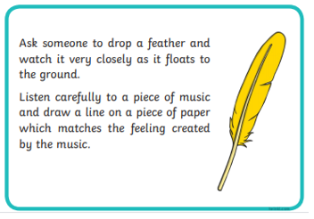

1. **Creative Activity**

Michael Rosen has returned home in recent weeks after being in hospital with Covid-19. This article goes into more detail - He has made an amazing recovery.

<https://www.theguardian.com/books/2020/jun/24/michael-rosen-home-from-intensive-care-after-coronavirus>

You could look at his website <https://www.michaelrosen.co.uk/> to remind yourself of his amazing work and then write him a letter to celebrate his return home.

1. **Social / Emotional Activity**

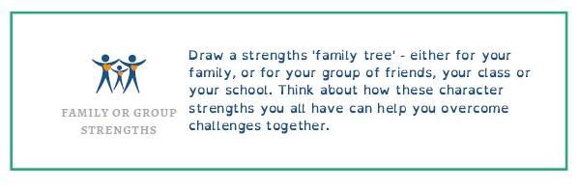

1. **Physical Activity- See the link to this on the ‘COVID 19’ Button on our Homepage of the Website**

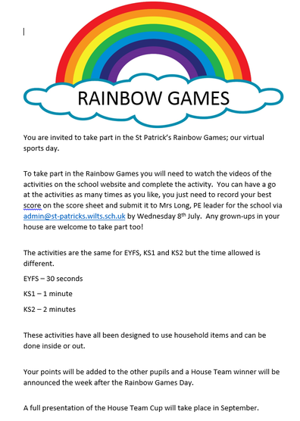

1. **Spiritual / Reflective activity**

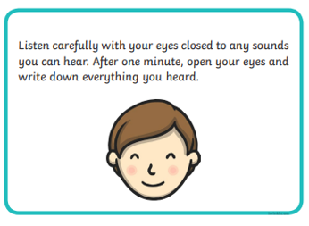

1. **Supporting the Community Activity**

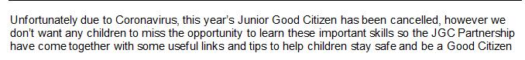

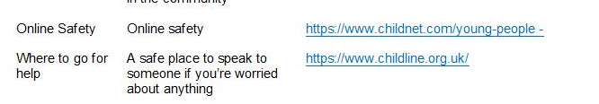

1. **Craft Activity**

Could you create your own coat of arms? Have a look on our website, go to the COVID tab and then select ‘Resources’. This will take you to a template and PowerPoint which tells you in more detail how to complete this challenge.

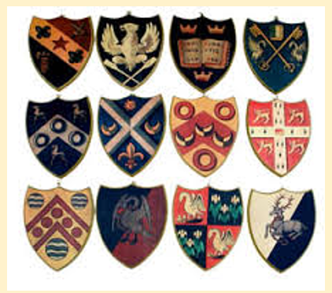

**Reading to Relax**

Don’t forget to sign up for the Summer Reading Challenge!



**Maths**

Day 1

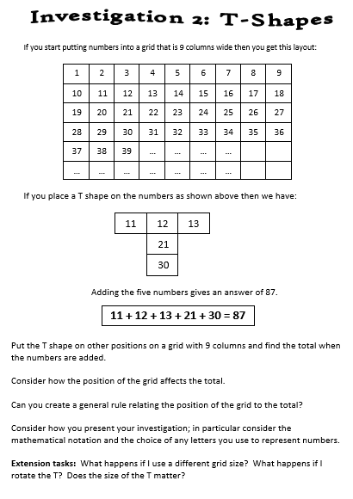

Day 2

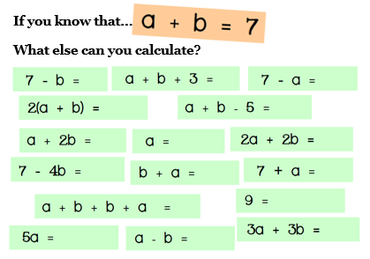

Day 3

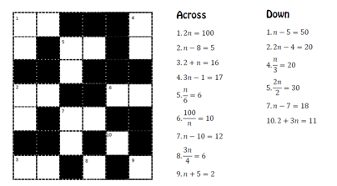

Day 4

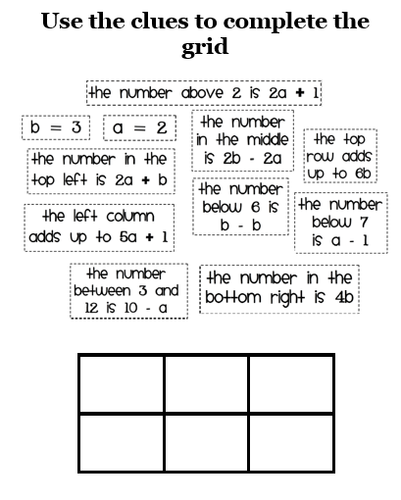Day 5

