**Home Learning – Lockdown Challenges for Year 2**

**Term 6 Week 6 6th July 2020**

[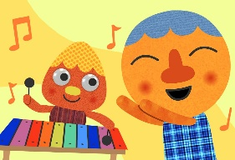](https://www.google.com/url?sa=i&url=https://supersimple.com/song/my-happy-song-featuring-noodle-pals/&psig=AOvVaw0tUmWULuHrGICsX5P6F6y_&ust=1592988053003000&source=images&cd=vfe&ved=0CAIQjRxqFwoTCODjjo_Fl-oCFQAAAAAdAAAAABAE)

1. **Music / Drama / Dance Activity**

Get started, experimenting with music. Explore the different elements that make up a song, play or clap along with the music and make your own version of a song, then listen back to it.

This is the link you need for the BBC website**:**

[**https://www.bbc.co.uk/teach/bring-the-noise/eyfs-ks1-music-play-it-bring-the-noise/z4sq92pExperiment**](https://www.bbc.co.uk/teach/bring-the-noise/eyfs-ks1-music-play-it-bring-the-noise/z4sq92pExperiment)

Play It! contains five songs with more to come soon so you can get musical with ***I am a Robot***, ***Hands in the Air***, ***Take You Home***, ***Be in the Band***, ***Bring the Noise*** and ***Spooky World***.

1. 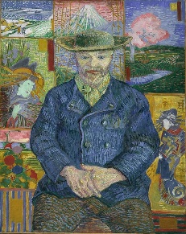**Creative / Craft & Design Activity**

We started Year 2 with self-portraits for one of our class displays. You’ve learned and grown such a lot this last year, can you now do a self-portrait of yourself as you have looked during the last few months. Some children are still wearing their school uniform, others are wearing their PJs! What do YOU look like now?



1. [](https://www.google.com/url?sa=i&url=https://www.quora.com/Why-do-clouds-have-different-shapes&psig=AOvVaw34XVI1yHP5-hX9HxchPQG9&ust=1592991788495000&source=images&cd=vfe&ved=0CAIQjRxqFwoTCOC49f_Sl-oCFQAAAAAdAAAAABAN)**Social / Emotional Activity**

Play Kindness Bingo! (see attached sheet) How many squares can you complete this week?

1. **Physical Activity**

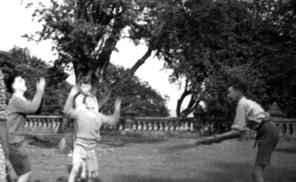Anastasia’s family have been learning how to play rounders this term. Can you learn a new team game to play with friends and family? Take time to learn the rules for a new game and then practise the skills needed to play that game. When you’re ready to play, play the best you can and follow those rules.

French Cricket is a favourite of ours - there’s nothing French about it and you use a tennis racket! What game can you play now?

[](https://www.google.com/url?sa=i&url=https://www.youtube.com/watch?v%3D7XSrjv_Aga4&psig=AOvVaw3KTXv5RhwoQDsqp9dwZama&ust=1592991937122000&source=images&cd=vfe&ved=0CAIQjRxqFwoTCLDd-M_Tl-oCFQAAAAAdAAAAABAD)

1. **Spiritual / Reflective activity**

Have some quiet time to yourself. Think of 5 brilliant things that you have in your life that you are thankful for. You might link these to things you put in your Happiness Box. You could listen to some music and draw them, or you could have some silent thinking time and give thanks to God for them.

1. ****Supporting the Community Activity**

If you see some litter when you are out on one of your family walks, pick it up and throw it away safely. You could do a poster to remind people to pick up their rubbish and not drop it on the ground. Why don’t you display it on your window to remind people as they walk past your house or put it up in a sensible place in your community.

1. [](https://www.google.com/url?sa=i&url=https://www.allmomdoes.com/2017/07/06/reading-is-fun-how-to-make-summer-reading-fun-for-your-kids/&psig=AOvVaw1qB0AVQswovH9ZgK0TL6Ox&ust=1592992160794000&source=images&cd=vfe&ved=0CAIQjRxqFwoTCLD327fUl-oCFQAAAAAdAAAAABAD)**Reading to Relax**

Choose some of your favourite books. Snuggle down on the sofa or in your bedroom or in the garden and enjoy reading them again and again. You could read them with members of your family too. You could read aloud to them or take it in turns to read a page each. Can you add expression to your voice?

*Remember there is the ‘Rainbow’ Talk for Writing pack and the Maths booklets that you can access on the class webpage too if you would like to.*

* We are hoping to see lots of you on Wednesday for your ‘Keeping in Touch’ session (see the newsletter), either 11.00-12.00 or 1.00-2.00pm. You need to email school by* ***FRIDAY 3rd JULY*** *if you would like to come: admin@st-patricks.wilts.sch.uk. You will then get a parent mail on Monday 6th July to tell you the time of your session. Please bring your Happiness Box with you if you would like to talk about it with your class friends. Alternatively you can do a short talk, as detailed in the newsletter: Prepare a very short (1 - 2mins) talk / presentation on something that you have learnt to do (eg. learnt to juggle or knit), practised and improved (eg. drawing, playing an instrument) or conquered a challenge (eg. tidied your bedroom, learnt all your tables etc.) You may bring in an example if you wish. Powerpoint presentations are not necessary, as hopefully, we will be outside.*