**Home Learning – Year 6**

**Week 1 – Answers**

**Maths**

Daily Arithmetic

|  |  |  |  |  |
| --- | --- | --- | --- | --- |
| Day 1 | Day 2 | Day 3 | Day 4 | Day 5 |
|  |  |  |  |  |

Investigations:

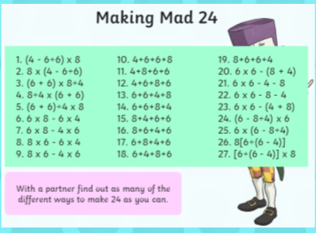 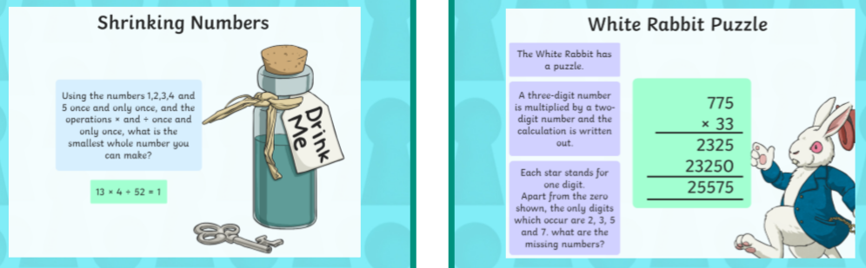

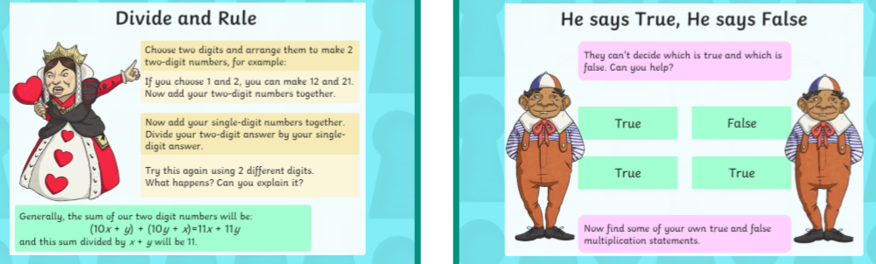

**Reading Comprehension:**

1. What happened after the birds crowed? The air was filled with a beating of a gong.
2. What does the phrase –their relief was short lived mean? It didn’t last for long.
3. Can you give another word for ‘halted’? Stopped
4. Draw a sketch of Stormy Point- adding as many details as you can.