Monday 1st June
Reading and measuring capacity. We measure small amounts of liquids in millilitres-ml
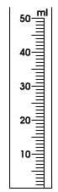
Getting going-colour the jugs to show the right amount of (blue ) water.

10ml 25ml 42m

Write the amount of water in the jug-check the scales first-they are all different
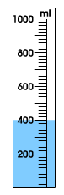
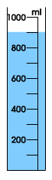
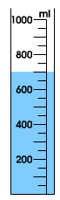
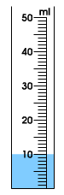

……………ml …………...ml ……………ml ……………ml

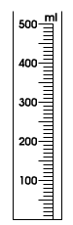
Now colour the jugs to show these amounts of water.

20ml 35ml 150ml 450ml

Write the amount of water in the jugs-check the scales first-they are all different
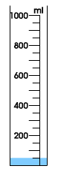
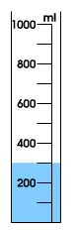
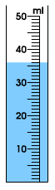

……………ml …………...ml ……………ml ……………ml ……………ml

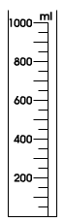
Now colour the jugs to show the amount of water- remember-all of these scales are different!

42ml 250ml 500ml 450ml 750ml

