Home Learning
Year 1 – Term 5 Week 2
27th April 2020

Reading:
- Look at the front cover of a book you haven’t read and make a prediction on what you think the book will be about. Read the blurb and add to your prediction. Think about where the story might be set, the characters you think may be involved in the story and what you think will happen. Use the following sentence stems: I wonder if, I bet, I imagine, I think x will happen next…because…
- Try and pick a book that is a little different to the one that you picked last week.
- Read the book and summarise in a few sentences what the book was about. Was your prediction correct?
- Answer the questions in the back of your book. If you are using the online resources, there are activities to go with each book.
- Read the book over the week. On Friday, sit your teddy bears in a circle and read them the book like a teacher would.

Big Cat books have made their books available on line during school closures. This link will give you a password and link. Please look at the Big Cat section and together you can pick a fiction or non-fiction book (look at the banding of their current reading book to guide your choice).

https://collins.co.uk/pages/big-cat-ebooks

English:
Diary entry
- Keep up writing your daily journal each day.
Draw a picture and write about what happened.
I felt… I liked… because……
How can you make your writing interesting? Can you add at least 3 interesting words?
- Think about the positive things that have happened in your day. When you reread your diary each day, these memories will help you to focus on the great things that are happening.

Story writing

Have a look at this picture….
Monday: What characters live in this castle? Draw a picture of the characters and write a short description of each one.
Tuesday: What exciting event has happened inside the castle? Is it a celebration? Something dangerous? Something mysterious? Draw a picture of your idea and write some notes about it.
Wednesday: Create a story map using your characters and exciting event. Think about the beginning, the middle and then end.
Thursday: Time to start writing your story!
Friday: Edit and check your story, you could even publish it into a book! We would love to see a photo of what you have written, send it to the school office and we can see.

Spellings: All the spellings for Term 5 were sent to you before Easter. Please see and practise.

Phonics: Daily phonics lessons are online. Please see phonics letters for the times of lessons and how to access them. Don’t forget the flash cards are there to watch on our class page!

Maths:
Time: Fluency
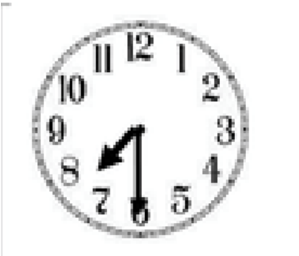
Look at the clocks below. Can you match the corresponding times for each? Use the sentence stems to help explain your choices. For example

Half

seven

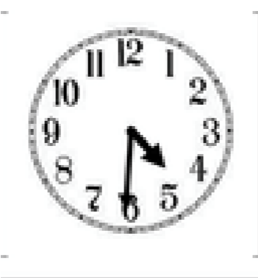
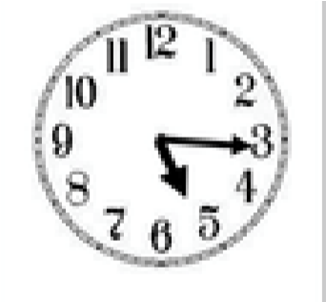
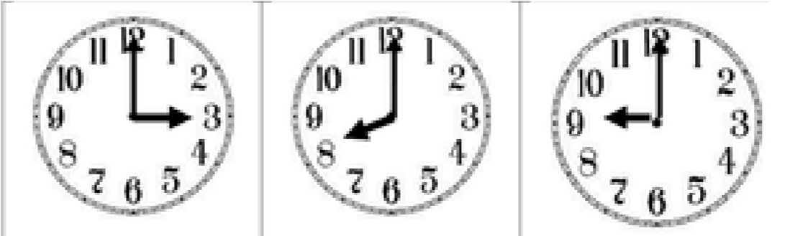
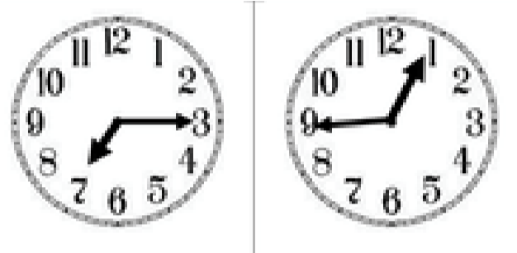
:

Half past six quarter to one eight o clock three o clock

Quarter past seven half past four nine o clock

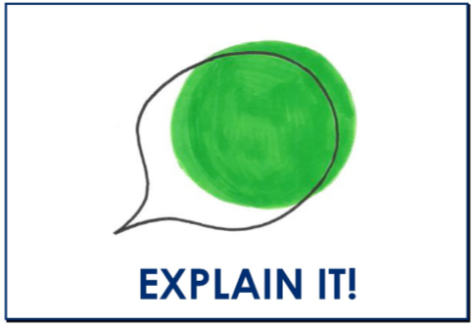
What of these times is when you wake up?

I know that… is when I wake up because ___________

Reasoning:
Mrs Sykes says that this clock shows half past 12.
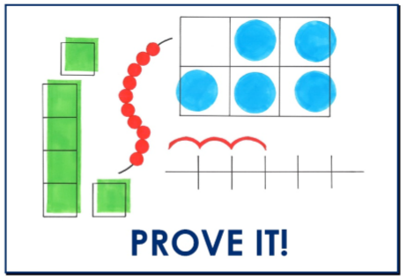
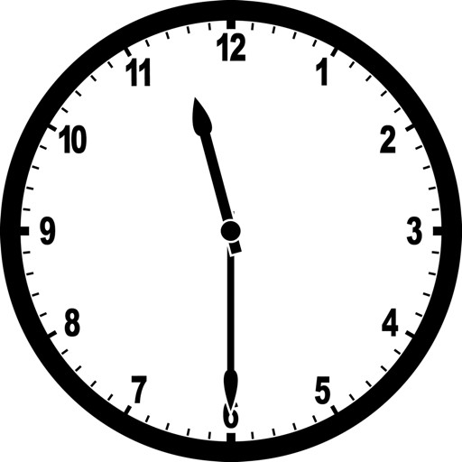

True or false?

Application:
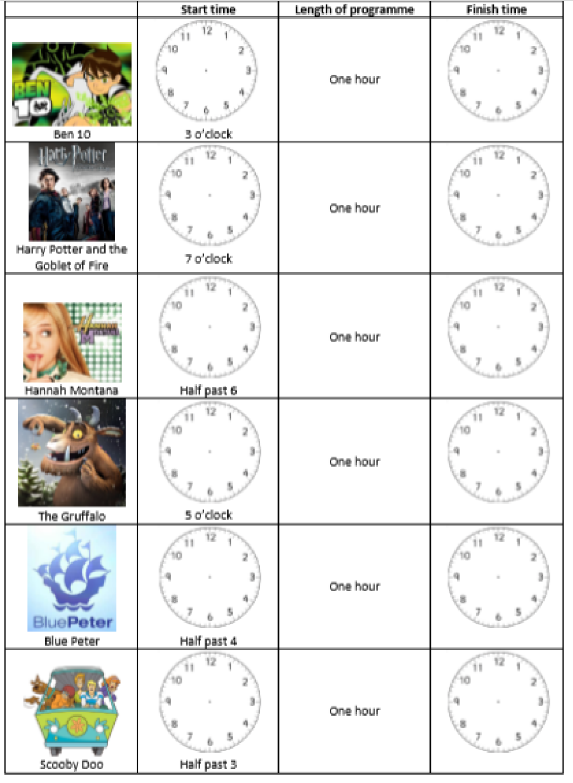
Now that you have practiced your time knowledge, here’s a timetable for Mrs Solomon’s TV shows. Can you fill in the start time and then the finish time?

Religion:
Read the first account of the Resurrection – and discuss the question prompts within the story with an adult.

After Jesus had died, some of the woman decided to go to the tomb where Jesus was buried. When they got there they found the stone rolled away from the tomb. They were really puzzled. Who could have done this they asked each other. They went in the tomb. (What do you think they were expecting to see?) and found that the body had gone! What they saw was a young man sitting on the right side, dressed in a white robe; they were really surprised and a little bit scared. (Why do you think they were a bit frightened? What else might they be feeling?) (This wasn’t Jesus- who do you think it might be?) The man said to them, “Do not be frightened; you seek Jesus of Nazareth, who was crucified. He has risen, he is not here; see the place where they laid him. But go, tell his disciples and Peter that he is going before you to Galilee; there you will see him, as he told you.” (How do you think the women are feeling now? If they go back and tell the disciples do you think the disciples will believe them? )

Draw faces to show how the women felt on their way to the tomb and then at the tomb and finally after they hear the news.
Look at the different Easter cards. Which cards do you think are connected to the story? Why?



Create your own Easter card, thinking about the symbols and colours you might use to link it to the story.

Science:
The life cycle of a plant
https://www.bbc.co.uk/bitesize/topics/zpxnyrd/articles/z2vdjxs
Watch the video clip about the life cycle of a plant and then either
- Do the quiz that follows on from the video
or
- Draw the life cycle of a plant in your book.

History: Kings and Queens!
Who was Henry the 8th and why was he such a famous King.
Can you find out 5 facts about this famous King? Which fact is the most interesting?
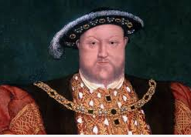

Geography: Where does my food come from?
What jobs do you think a farmer has? Make a prediction about all the things a farmer has to do each week? Research the jobs of a farmer and see if you were right. If you know a farmer you could interview them on the phone.

Art
Just for fun 3d jellyfish create your own 3d jelly fish. You could use paper bowls, card or paper and design them however you wish.
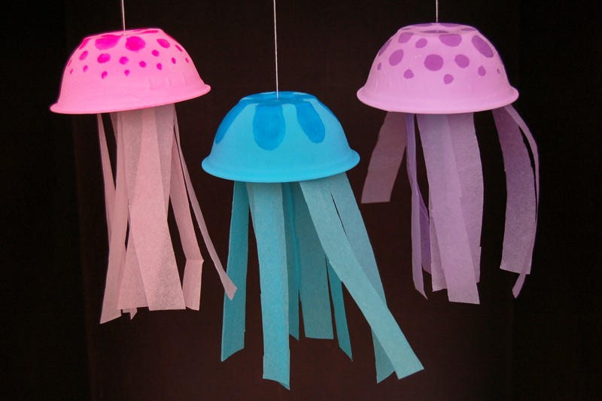
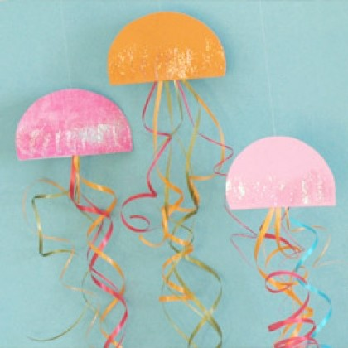
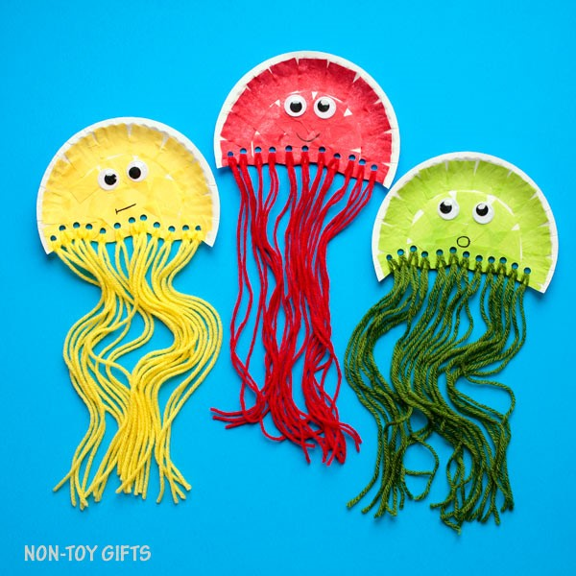

RE:

Grammar and Punctuation:
What is wrong with these sentences? Can you write them down and correct the mistakes.

how old are you!

my name is bob.

It was sunny and so i went outside

PE
Oti Mabuse is live streaming dance lessons for children at 11.30am every day. There is a bank of some fantastic dance routines on her You Tube Channel. This week her theme is Musicals!

Mindfulness

Belly Buddies
(10 minutes)
- Find a small stuffed toy in your house.
- Find a calm quite place and lay on your back. Place the toy or object on top of your belly button.
- Calmly breathe in and out, watch the object as it moves up and down with their breath. Discuss with children the importance of breathing of we want to calm our bodies and relax

