**Home Learning – Year 6**

**Week 5 – Answers**

**Comprehension Questions**

1. Area
2. The tropical rainforest is home to a wide variety of animals.
3. They are plants that can survive in very dry conditions
4. Prevalent

Synonym = common

Antonym = rare

**Grammar**

1. Repetition
2. Suspense
3. Repetition
4. Repetition
5. Subordinate clause

Daily Arithmetic Answers:

|  |  |  |  |  |
| --- | --- | --- | --- | --- |
| Monday | Tuesday | Wednesday | Thursday | Friday |
|  |  |  |  |  |

Day 1 Investigation:

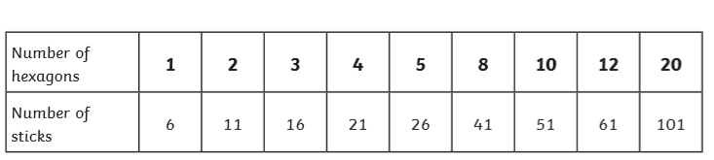

Day 2 Investigation:

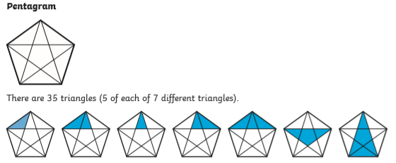

Day 3 Investigation:

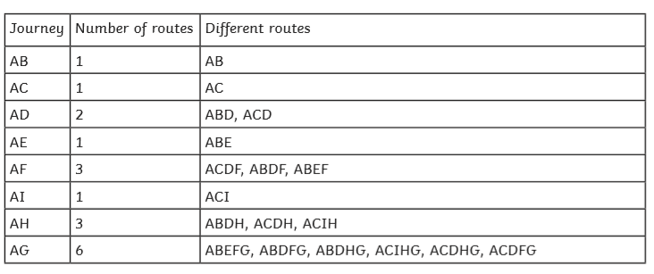

Day 4 Investigation:

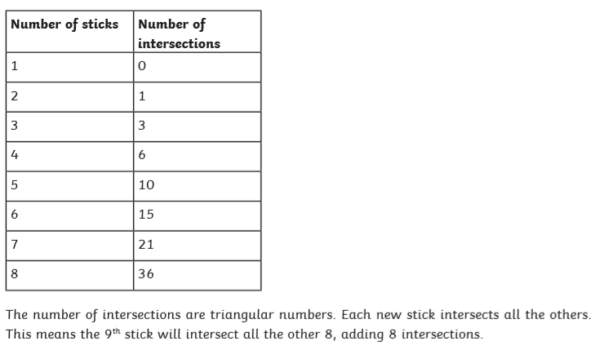

Day 5 Investigation:

