**Home Learning – Lockdown Challenge**

**Term 6 Week 5 - 29th June 2020**

[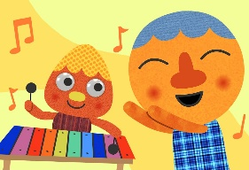](https://www.google.com/url?sa=i&url=https://supersimple.com/song/my-happy-song-featuring-noodle-pals/&psig=AOvVaw0tUmWULuHrGICsX5P6F6y_&ust=1592988053003000&source=images&cd=vfe&ved=0CAIQjRxqFwoTCODjjo_Fl-oCFQAAAAAdAAAAABAE)

1. **Music / Drama / Dance Activity**

Choose 10 of your favourite songs which make you happy. Create an album cover design for your songs whilst listening to it!

1. **[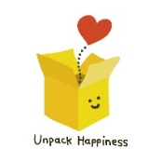](https://www.google.com/url?sa=i&url=https://www.teepublic.com/pin/5552997-unpack-happiness-box&psig=AOvVaw2Eicq0xbZ6-iJPc17AZWRD&ust=1592913012109000&source=images&cd=vfe&ved=0CAIQjRxqFwoTCNj738etleoCFQAAAAAdAAAAABAG)Creative / Craft & Design Activity**

Make your own happiness box, filled with things that make you feel happy! On the school website welcome page, there is a video of Miss McLoughlin explaining the items in her box to show you as an example. Mrs Robertson and I have also put a video of our boxes on the Year 2 page. I wonder what you will put into yours?

1. [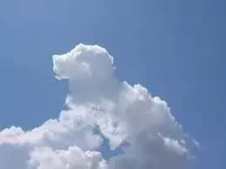](https://www.google.com/url?sa=i&url=https://www.quora.com/Why-do-clouds-have-different-shapes&psig=AOvVaw34XVI1yHP5-hX9HxchPQG9&ust=1592991788495000&source=images&cd=vfe&ved=0CAIQjRxqFwoTCOC49f_Sl-oCFQAAAAAdAAAAABAN)**Social / Emotional Activity**

When you are out in your garden or at the park with your family, lie down and watch the clouds go by. See what different shapes you can spot. Can you find any that resemble animals? Share what you find with each other, you might all see different things!

[](https://www.google.com/url?sa=i&url=https://community.localmasters.com/guidelines-to-embrace-yoga-in-your-day-to-day-life/&psig=AOvVaw1RsJUjpOV7eX7nyv_C6944&ust=1592991832689000&source=images&cd=vfe&ved=0CAIQjRxqFwoTCJimqZ3Tl-oCFQAAAAAdAAAAABAE)

1. **Physical Activity**

<https://www.youtube.com/watch?v=dF7O6-QabIo> Join Adriene for a rainbow yoga session on YouTube. When you finish, make a note of how you feel after doing the activity.

[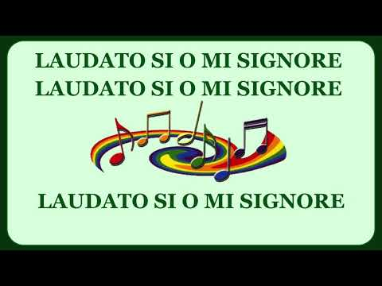](https://www.google.com/url?sa=i&url=https://www.youtube.com/watch?v%3D7XSrjv_Aga4&psig=AOvVaw3KTXv5RhwoQDsqp9dwZama&ust=1592991937122000&source=images&cd=vfe&ved=0CAIQjRxqFwoTCLDd-M_Tl-oCFQAAAAAdAAAAABAD)

1. **Spiritual / Reflective activity**

[](https://www.google.com/url?sa=i&url=https://www.publicdomainpictures.net/en/view-image.php?image%3D201827%26picture%3Dha-ha-writing&psig=AOvVaw1M3gyzrLpZHBqZsjbrGP3u&ust=1592992104328000&source=images&cd=vfe&ved=0CAIQjRxqFwoTCIih8JbUl-oCFQAAAAAdAAAAABAD)Choose your favourite hymn. Can you make a PowerPoint presentation to show the lyrics and add pictures to match the theme of the hymn? We could use these next academic year for hymn practice! Some examples would be ‘The Light of the World’ by Stuart Townend , ‘Our God is a great big God’ (<https://www.youtube.com/watch?v=eSTfM8M2Md8>), Colours of Day and ‘ All are welcome’ (<https://www.youtube.com/watch?v=js8RtT0mJpc>)

1. **Supporting the Community Activity**

Write some jokes to post to a neighbour to make their day! Check your material makes your family laugh before you send them!

1. [](https://www.google.com/url?sa=i&url=https://www.allmomdoes.com/2017/07/06/reading-is-fun-how-to-make-summer-reading-fun-for-your-kids/&psig=AOvVaw1qB0AVQswovH9ZgK0TL6Ox&ust=1592992160794000&source=images&cd=vfe&ved=0CAIQjRxqFwoTCLD327fUl-oCFQAAAAAdAAAAABAD)**Reading to Relax**

Find a book with lots of different characters where you can practise different voices. Make some loud, quiet, funny, strange and then read aloud to a member of your family and shock them with your expression.