MY MANGONEL PROJECT

By Rupert Pearce.

Introduction

* Why did you start this project? Because I was interested in them.
* What were catapults used for? tHey were used to destroy castles
* When were they used? The time of the romans until they were eventually replaced by gun powder.

1. We researched types of catapults

What types of catapult are there?

Mangonel – uses a spring to throw stones

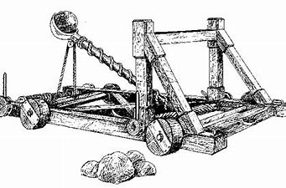

Ballista – big bow.

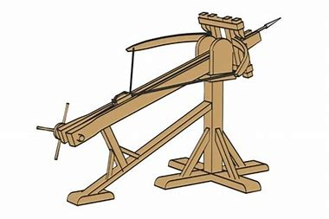

Trebuchet – uses weight to throw rocks

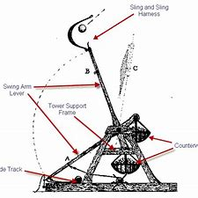

We made a mangonel. To make the torsion spring that powers the catapult we used a boot lace that we wound up very tight before firing.

Then we looked at examples to see how other people did it.

Then we got to work!

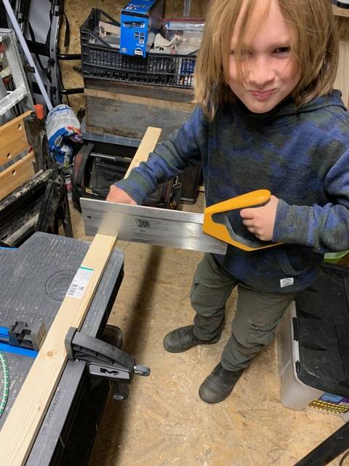 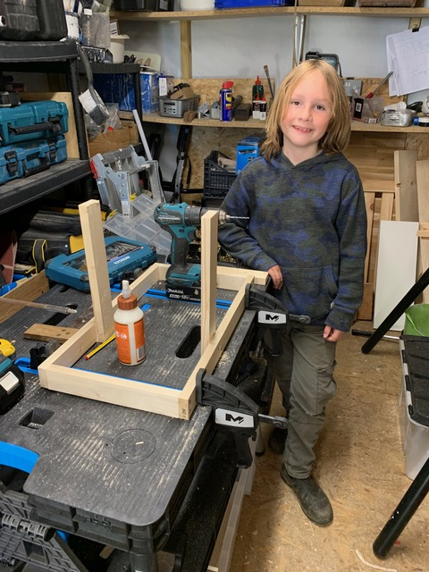 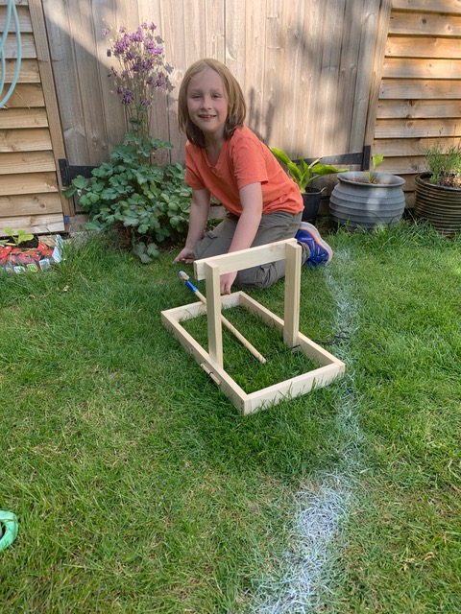

How did it work?

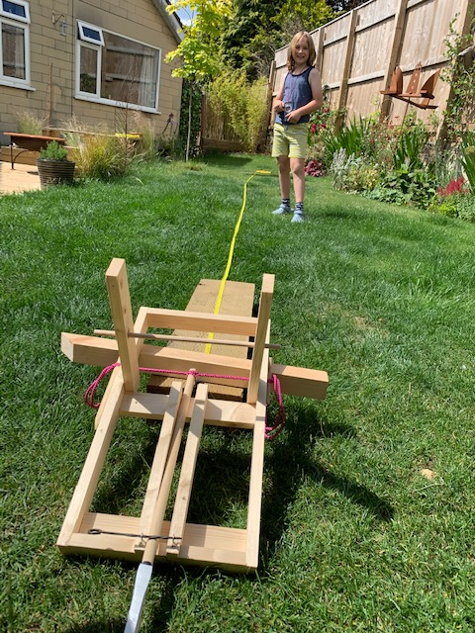 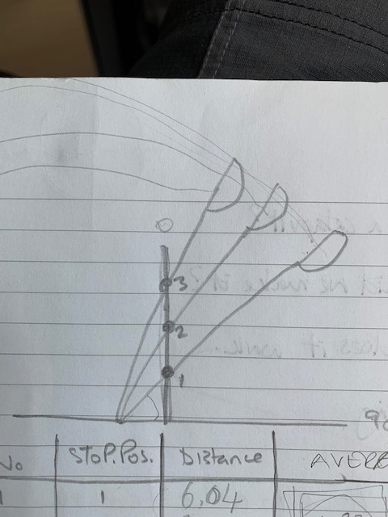

We tested it by firing an almond in its shell 3 times from the lowest stopper to the highest stopper position. We thought it would go further when we used the lowest stopper. This is what happened.

|  |  |  |  |
| --- | --- | --- | --- |
| Firing | Stopper Position | Distance in metres | Average distance |
| 1 | 1 | 6.04 |  |
| 2 | 1 | 7.25 |  |
| 3 | 1 | 7.19 | 6.80 |
| 4 | 2 | 5.10 |  |
| 5 | 2 | 4.90 |  |
| 6 | 2 | 4.10 | 4.70 |
| 7 | 3 | 5.67 |  |
| 8 | 3 | 4.10 |  |
| 9 | 3 | 3.00 | 4.30 |

So it sort of went as we thought; the lowest stopper position made the almond go higher and further. This is called the release angle.