**Home Learning**

**Year 6 – Term 5 Week 3**

**4th May 2020**

# Reading

This is a great opportunity to read some good books – if you don’t have your Green Record at home please keep a record of your reading in the back of your school exercise book.

Can you complete the tasks below during the week?

* **Read at least a chapter a day**. Ask questions about the book. Think carefully about questions that will help you to understand the text. (Allow about 15 minutes, not only at bedtime)
* Pick out any new words that you need to clarify (or select some of your choice). How can you find out what it means?
  + Read around the word – the paragraph, or sentences before and after it
  + Look for a root word
  + Try and exchange it with another word that would make sense
  + Look it up in a dictionary
  + Ask someone to help you
* Write a list of these new words and try to use them when talking or writing.

Here are a couple of recommendations, or follow <https://schoolreadinglist.co.uk/reading-lists-for-ks2-school-pupils/suggested-reading-list-for-year-6-pupils-ks2-age-10-11/> for more ideas.

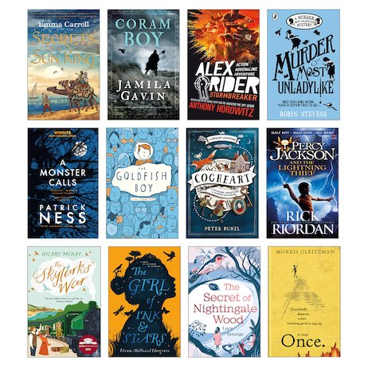

If you’ve been reading the same book since we finished at school now may be time for a change!

Here are some ideas. I know the library is closed but.. you are able to ‘borrow’ digital audio books from Wiltshire libraries without charge if you are a member.

Go through your bookshelves and revisit some old favourites. Your parents may have some recommendations too!

|  |  |
| --- | --- |
| **Metamorphosis**  Metamorphosis is a process by which animals undergo an abrupt and obvious change in the structure of their body and their behaviour. Some animals undergo complete metamorphosis in which they completely transform. Other animals experience incomplete metamorphosis where they go through several different stages with each stage getting bigger than the last.  Complete metamorphosis has four distinct stages: egg, larva, pupa and adults (for example a frog or butterfly) and the animal looks very different at each stage. | Incomplete metamorphosis has three distinct stages: egg, nymph and adult (for example a dragonfly or grasshopper) and the young animal (nymph) looks like a smaller version of the adult.  **Comprehension Questions**   1. Find and copy two words in the text that mean the same as ‘change’. 2. Name two animals from the text that go through complete metamorphosis. 3. Describe two ways in which complete and incomplete metamorphosis are different. 4. Explain why the word ‘abrupt’ has been used to describe metamorphosis. |

* Comprehension Task – please read the text and answer the questions using sentences in your notebook.

**English Writing**

**Day 2**

Write your autobiography. It should be in first person and in chronological order. You could use these headings:

Introduction and Early Life

Greatest Achievements (age 4-8)

Most recent achievements.

Hopes and aspirations for the future.

Please start the week spending a couple of days on your Autobiography. **Day 1** Start by gathering information. Ask your family for their opinions. What do they think the most important things about you are? What do they think you’re good at? What do they think are the most significant events of your life so far?

(This might be a good chance to get the photo albums out!)

What do you think you’re good at? What are your proudest moments? What are your greatest achievements?

**Grammar**

**Modal Verbs and Adverbs of Possibility**

**BBC Bitesize have a number of lessons online.**

**If you would like to do this lesson online follow:**

<https://www.bbc.co.uk/bitesize/articles/z4y492p>

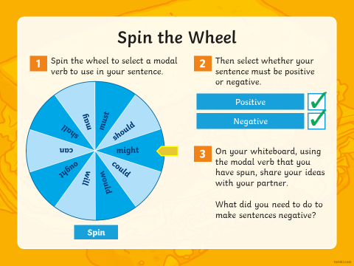

# Spellings

Spellings

There are 10 spellings to learn each week. Use a dictionary or google to check the definitions of words you don’t know and use them in sentences. Could you find their synonyms and antonyms? What is the root word of each word? Use the look, say it, cover, write, check strategy to test yourself.

‘ent’ words

recent

intelligent

innocent

frequent

accident

incident

confident

resident

agreement

employment

argument

**Maths**

Day 1-Four Number Operations

1. 543.12+454.63=
2. 17353+26218=
3. 9176-2004=
4. 41512-3612=
5. 3025x4=
6. 3.3x45=
7. 966.33/3=
8. 1296/9=

Day 1 Arithmetic:

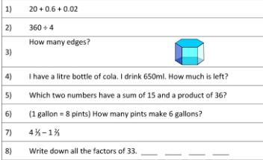

Day 1 investigation:

Make your own net which folds into a 3D shape of your choice (cube/ pyramid/ cone- how challenging can you make this?)

Day 2-Four Number Operations

1. 917.65+ 112.31=
2. 49769+42126=
3. 7551-2522=
4. 55243-2711=
5. 2306x6=
6. 5.3x33=
7. 84.888/4=
8. 5922/9=

Day 2 Arithmetic:

 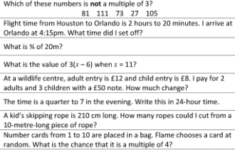

Day 2 Investigation:

If you roll a dice 100 times which number would you roll the most? Give a reason for your answer and then try it out. Can you record your answers using a tally chart?

Day 3-Four Number Operations

1. 46.411+ 23.488=
2. 484673+4234=
3. 95952-21011=
4. 19821- 1492=
5. 6053x5=
6. 5.3 x56=
7. 8642.2/2=
8. 2997/3=

Day 3 Arithmetic:

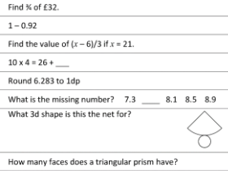

Day 3 Investigations:

Choose a number from the list below:

2 4 5 6 7 8 9

Multiply each number by ten times itself (2x2x2x2x2x2x2x2x2x2)

What pattern do you see?

Day 4-Four Number Operations

1. 21.218+ 26.521=
2. 99942+1449=
3. 776685-12132=
4. 8761-999=
5. 9018x7=
6. 3.3x57=
7. 846.26/2=
8. 7911/8=

Day 4 Arithmetic:

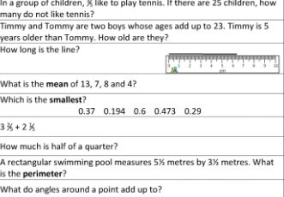

Day 4 Investigation:

Using just scissors and a piece of A4 paper, what is the longest piece of paper you can make?

Day 5-Four Number Operations

1. 553.28+ 226.41=
2. 5887+ 12521=
3. 67681- 50470=
4. 65101- 781=
5. 4015x3=
6. 5.4x 33=
7. 699.36/3=
8. 15688/2=

Day 5 Arithmetic:

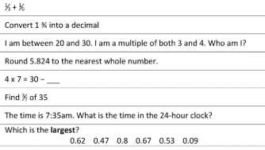

Day 5 Investigation:

How long have you been at school? Can you answer this as accurately as possible? Including years/months/days/hours/minutes/seconds?!

**Religion**

1. You could take part in the latest competition run by Clifton Diocese. This fortnight, it is another writing task – this time linked to the theme of New Life. This can be as creative as you wish - a Sci-Fi about discovering new life in space, a birth, new life on a farm - anything that connects to the topic. Entries should be less than 750 words and sent to [competition@cliftondiocese.com](mailto:competition@cliftondiocese.com) – Don’t forget to include your name and age.

Alternatively, if you wanted to send your entries to the school, we would love to read them ourselves and celebrate them on a class pages. We can also submit them to the Diocese. The deadline is not until **Friday 15th May**, so you have plenty of time to start planning your ideas!

2. Choose a creative way to pray for / send positive messages to the country’s NHS and key workers who are helping to save lives and keep the country going. You could write/draw/paint on pebbles, make prayer flags to hang outside or stick a daily prayer on the fridge and say this each time you open it during the day! If you try any of these ideas, or have come up with your own inventive ways of spreading hope and optimism at home, then help us to share your prayers by sending in photos.

[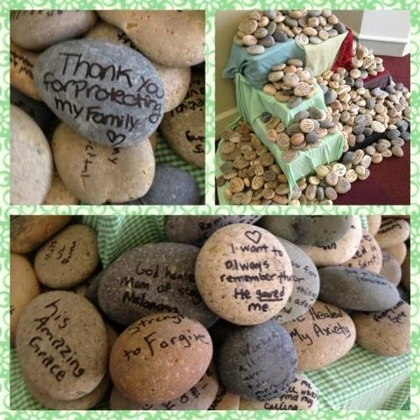](https://www.google.com/url?sa=i&url=https%3A%2F%2Fwww.pinterest.com%2Fpin%2F170010954656465451%2F&psig=AOvVaw3t_tppaGkr1pRf5OCG1JJf&ust=1588174454009000&source=images&cd=vfe&ved=0CAIQjRxqFwoTCLijjZO5i-kCFQAAAAAdAAAAABAK)

[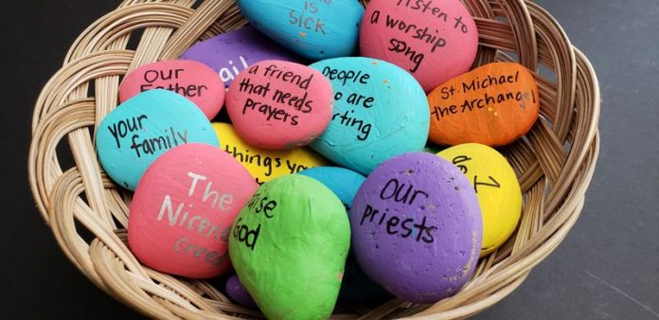](https://www.google.com/url?sa=i&url=https%3A%2F%2Fwww.catechist.com%2Fprayer-rocks%2F&psig=AOvVaw3t_tppaGkr1pRf5OCG1JJf&ust=1588174454009000&source=images&cd=vfe&ved=0CAIQjRxqFwoTCLijjZO5i-kCFQAAAAAdAAAAABAP)

[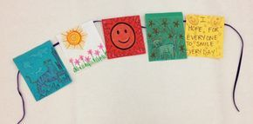](https://www.google.com/url?sa=i&url=https%3A%2F%2Fwww.pinterest.com%2Fpin%2F252553491584721355%2F&psig=AOvVaw1FCLbtosj2pkBdGEUR4wW-&ust=1588175398892000&source=images&cd=vfe&ved=0CAIQjRxqFwoTCOimi868i-kCFQAAAAAdAAAAABAK)

**3.** The Triduum

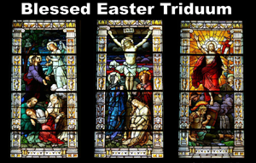

The Paschal Triduum reflects on the key elements of Jesus’ passion and resurrection, as told in the Gospels. It begins on the evening of Holy Thursday, reaches its most significant point during the Easter Vigil on Holy Saturday, and concludes on Easter Sunday.

Can you find out more about the liturgies on Holy Thursday, Good Friday and Holy Saturday, answering these questions?

1. What is another name for Holy Thursday?
2. What is remembered during the mass on Holy Thursday? Why?
3. What does the priest traditionally do during this mass? What is the meaning of this?
4. What is special about how the mass ‘ends’ on Holy Thursday?
5. What is remembered during the service on Good Friday?
6. The service on Good Friday is not a ‘mass’ as such. Can you explain why?
7. How does the Vigil service on Holy Saturday begin? What is the symbolism of this?
8. Many Christians are baptised following the mass, whilst others renew their baptismal promises. Why do you think this is?

**Science**

Complete a detailed diagram (pictures and labels) showing the lifecycle of a species of your choice. ( Use this week’s reading comprehension or the link below to help you!)

<https://www.bbc.co.uk/teach/class-clips-video/how-caterpillars-change-into-butterflies-no-narration/zn4rkmn>

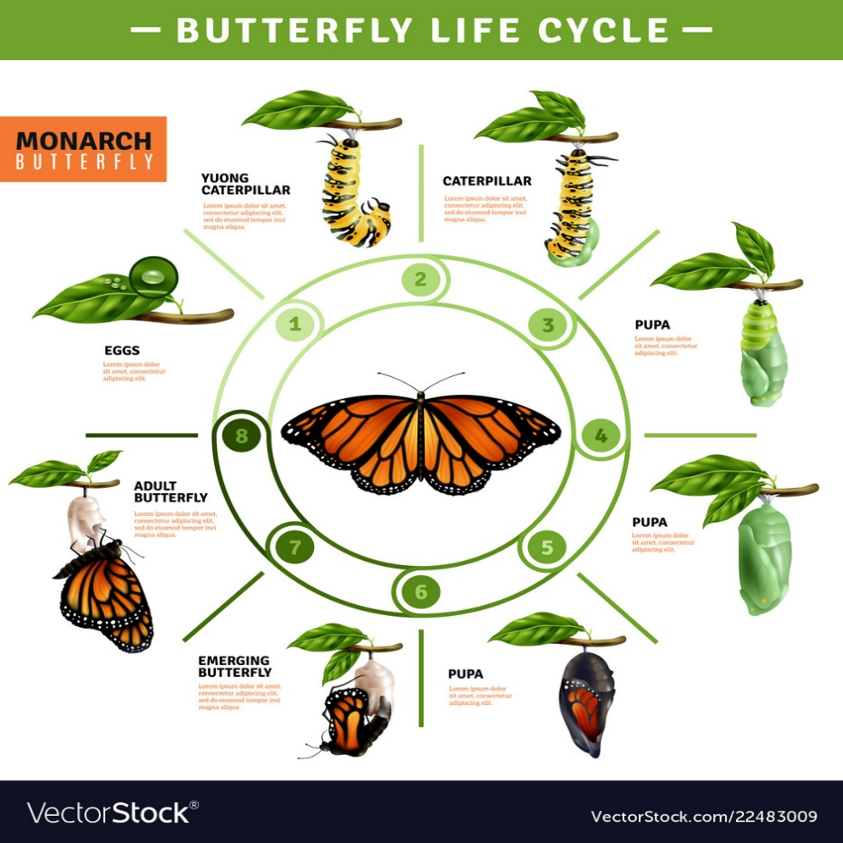

Art

Some of you may have heard of **Oak National Academy**. we will be building more of these lessons into our plans. To start with please follow the link to find this art lesson on texture.

<https://www.thenational.academy/year-6/foundation/texture-treasure-hunt-year-6-wk1-5/>

If you can’t access online. Have a go at making rubbings using different textures and pens and pencils. Can you build them into a collage?

History

https://www.bbc.co.uk/bitesize/topics/zq6svcw/articles/zs2ph39

Have a look at the website above. Watch the video with the different Mayan ruins.

Next see if you can do some research on the following Mayan ruins:

* Caracol
* Copan
* Tulum
* Calakmul
* Palenque
* Uxmal
* Tikal
* Chichen Itza

Now think of a way in which you might like to present you research. It could be as a tourist information leaflet, a poster or a PowerPoint for one or more of the ruins. Try to be as creative as possible. We would love to see what you come up with for our class gallery!

PSHE

In our conversations with parents and children this week the topic of transition to secondary school has come up. This in an exciting time but you may have some questions. In the Year 6 section on BBC Bitesize Lessons there is a whole lesson on transition to secondary. Perhaps you would like to look through with your parents.

<https://www.bbc.co.uk/bitesize/articles/zj2grj6>

**Useful Websites:**

<https://www.nhs.uk/change4life/recipes>- Cooking Ideas

professor assessor

<https://www.natgeokids.com/uk/> - for inspiring information about our planet.

<https://www.bbc.co.uk/bitesize> -lots of ideas and information.