Name _________________________ Date _____________

I can solve 1 and 2 step division word problems

( Don’t forget you can use pasta, counters, buttons, dots, crosses---anything you find…. to work out the answer)

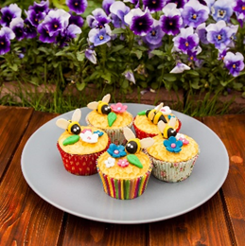

1. Verity makes 40 cakes. They need to be put into boxes. Each box holds 5 cakes. How many boxes will she need?
2. Alex and Emily each have the same number of teddies. They have 24 teddies between them. How many do they each have?

3. Isaac spends £24 on train tickets. Each ticket cost £4. How many tickets did he buy?

4. Lacey has 45 precious stones she has collected. She keeps them safe in special boxes. Each box holds 5 stones. How many boxes does she need?

5. Sam has 16 cards. He shares them equally between himself and his 3 friends. How many cards do they each get?

6. There are 20 **school days** left until the half term holiday. How many weeks is it until the half term holiday?



7. Noah has 40 sweets to share between himself and his 4 friends. How many sweets do they get each?

8. Mabel is sharing 120 new glue sticks between 10 classes. How many glue sticks will each class get?

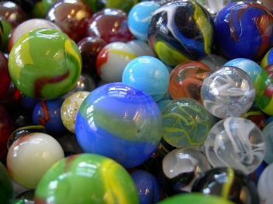9. Layton-Jai had 60 marbles. He gave away 35 marbles and put the remaining marbles equally into 5 bags. How many marbles were there in each bag?

10. Willow made 47 biscuits. She put 4 biscuits into each box.

How many boxes of biscuits were there?

How many biscuits were left over?

11. Anastasia divided 23 lollies equally between 5 of her friends and kept the ones left over (the remainder) for herself.

How many lollies did each friend get? How many did Anastasia eat?