**Home Learning – Year 6**

**Week 3– Answers**

**Day 1:**

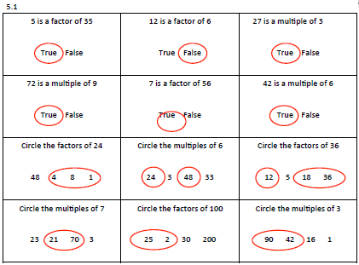

**Day 2:**

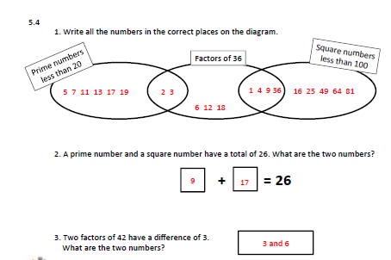

**Day 3:**

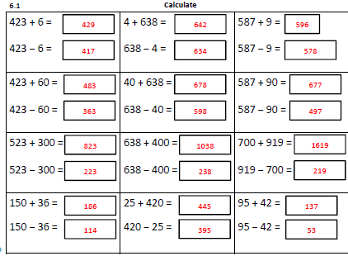

**Day 4:**

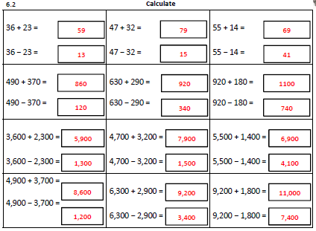

**Day 5:**

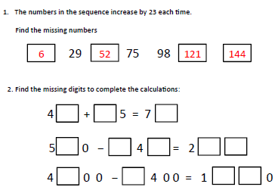

Reading answers- this week’s poem is very subjective so it is likely that you’ll have some quite different answers. This may be a good time to talk to a friend about their answers, did you write similar or different things?

