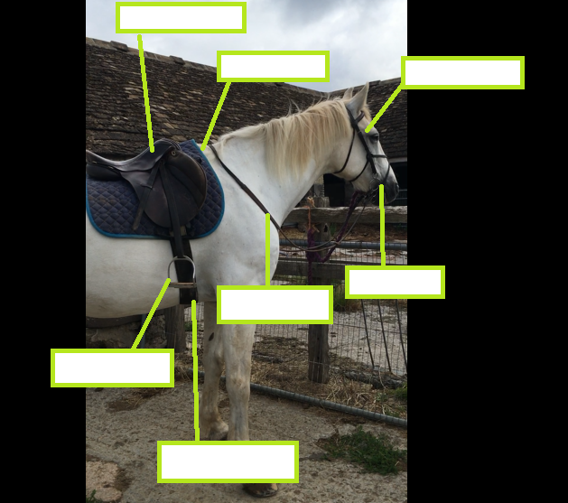

**Robbie measures 17.2hh. (17 hands and 2 inches) Each hand is 4 inches. Can you work out how many inches high he is? What about converting this to another measurement for example; cm, m, mm, ft?**

**In this video, Mrs Minty is taking her elderly horse out for a quiet ‘hack’. However, there are many different equestrian activities-** how many can you find?

**How many beats does each gait have?**

**WALK 2 BEATS**

**TROT 4 BEATS**

**CANTER 4 BEATS**

**GALLOP 3 BEATS**

***Which would you most like to have a go at and why?***

**Can you label the picture below with the correct words?**

**saddle girth stirrups reins bit bridle withers**

**Mrs Minty’s Equestrian Quiz!**