**Famous Landmarks Quiz**

**Can you name the famous landmark and where in the world you would find it? Use books, maps, the internet or even test your family as part of a family quiz night!** **(*Answers to follow on Friday*)**

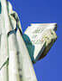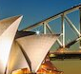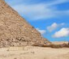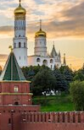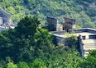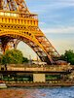 **1.**

**8.**

**7.**

**6..**

**5.**

**4.**

**3.**

**2.**

**9.**

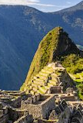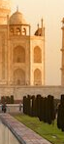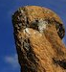

**10.**