Yoga ChallengeS from Miss Jones
1: Easy pose  This is the simplest of all poses that anyone can try. It’s good for the back, thighs and hips and it stretches the knees and feet.  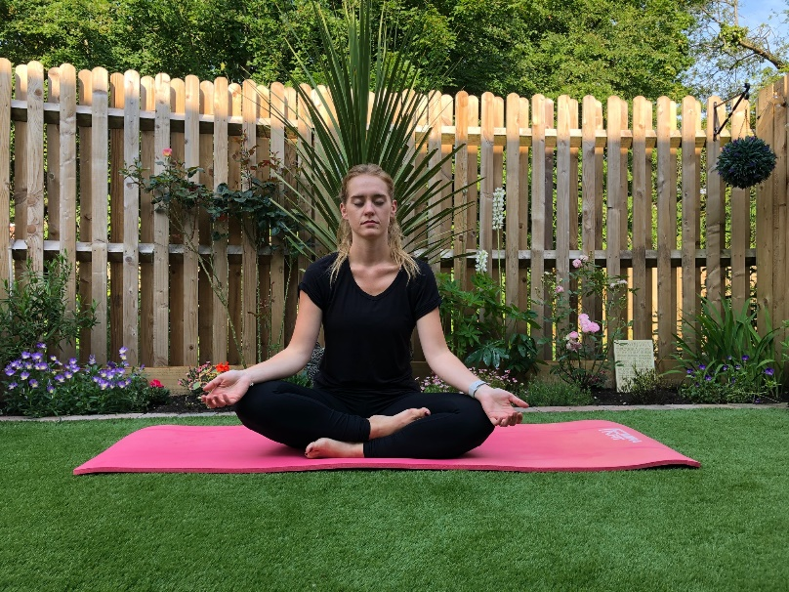 | 2: Tree pose  The tree pose teaches us the grace of a tree, standing tall and maintaining balance.  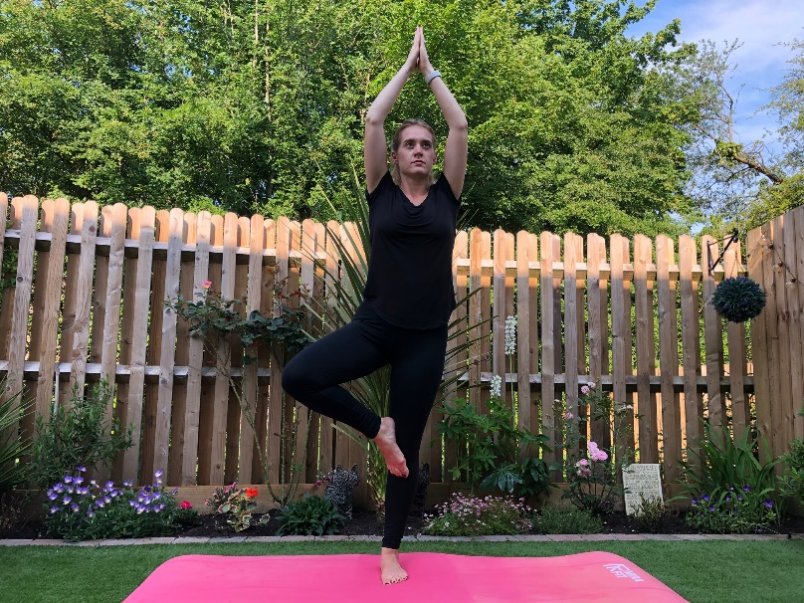
3: Cobra pose  The stretch can promote a sturdy back, abs, and strength.  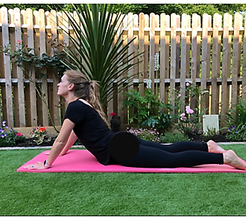 | 4: Bridge Pose  This rejuvenating backbend gives a good stretch to the spine and thighs.  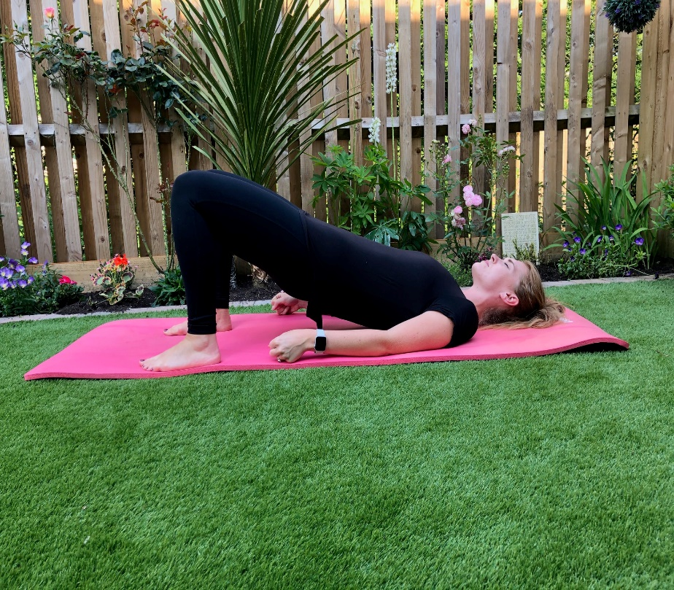
5: Cat pose  This pose relaxes and stretches the spine, neck and torso.  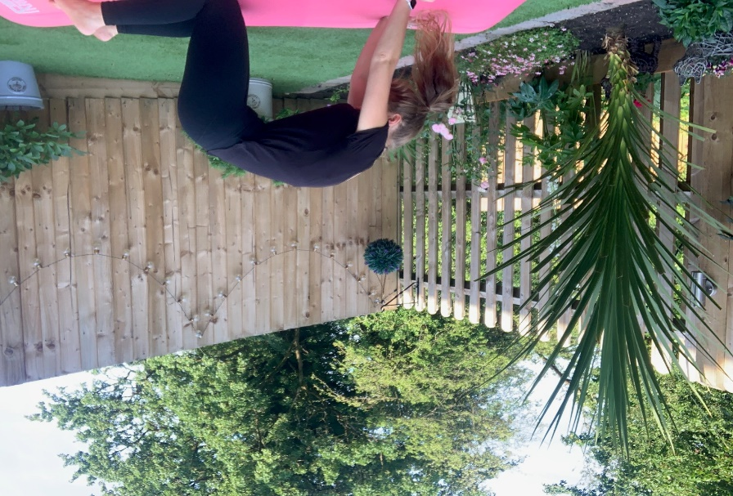 | 6: Butterfly pose  A pose that makes us flutter like a graceful butterfly, this is believed to stretch the thighs, knees, and hips.  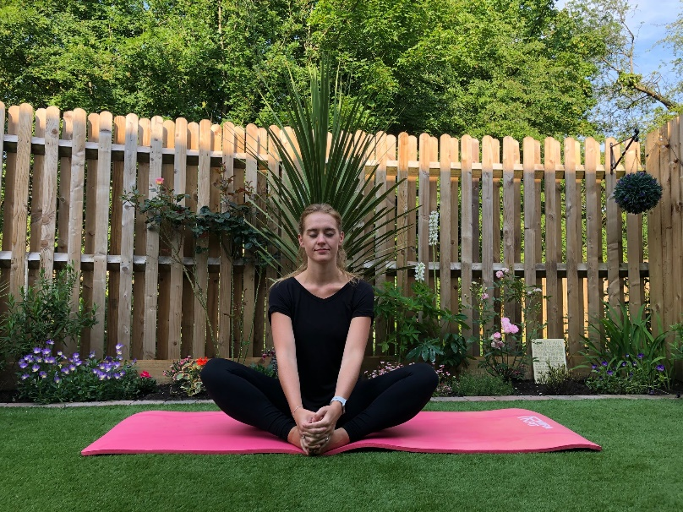
7: Downward-Facing Dog  This pose will strength the arms and legs, increase flexibility and invigorates the body.  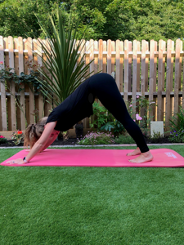 | 8: Mountain pose  This pose can be used as a cool down pose at the end. It improves posture, strengthens the thighs, legs, and ankles. It also firms the abdomen and hips and it can improve sleep.  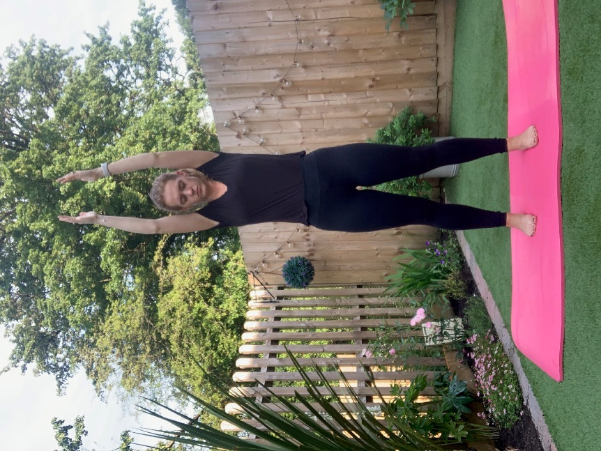
9: Boat pose
This balancing yoga pose helps to de-stress and feel rejuvenated. It strengthens the core, arm muscles, shoulders, and thighs.
