Thursday 4th June 2020

Dear Parents,

PLANS FOR OPENING SCHOOL TO MORE GROUPS IN WEEK 2 - Monday 8th June 2020

*At Saint Patrick’s our approach will be to start…….SAFE……...SMALL……...SLOW……….FAIR…….*

With 1st June indicating the beginning of phase 2 of the Government’s initiative to get more children returning to school, Saint Patrick’s saw an increase in numbers of children of key workers or vulnerable families attending in this first week. As a result, we were able to organise 4 Bubbles of children of similar ages, but not exclusively similar year groups. On Monday of this week, we sent an ParentMail to all parents asking you to indicate if you classified yourself as a key worker and sought a place for your child(ren) in week 2. The deadline for these responses was 9am yesterday, Wednesday 3rd June. Whilst this indication did not confirm a place, these total figures would then help us to determine the capacity of the school to take on more children.

Before opening the school up to a wider group of children, we have had to risk assess the size and safety of learning spaces and the adapted wider school environment, staffing capacity, timetables and routines, as well as our ability to regularly deep clean the school grounds*.*

To that end, we can confirm that in week 2, week beginning Monday 8th June, in addition to our usual groups, we will also be welcoming children from our Reception class on Monday 8th and Tuesday 9th June. Reception parents will have already indicated their wish to send their child back, and will have been contacted by us today, via Parentmail, to confirm their place in a new bubble next week.

Unfortunately, unless contacted by the school office, other children will not be able to come back to school next week.

CHANGES TO ARRANGEMENTS SINCE TERM 5

We now ask parents of key worker children or vulnerable families to indicate their wish to book places for EACH NEW WEEK by the previous Wednesday at 9am deadline. After this deadline, the school will be able to review risk assessments, staff capacity, school environment and the ability for us to maintain a regular deep cleaning regime.

Please be clear that, unlike Term 5, parents may not drop children into school on a casual basis without having booked a place the week before, as this will compromise the integrity of our Bubble groups. If the school does not have a record of your child’s name on the register for that day, then they will not be permitted to attend school.

Conversely, if your child is expected to attend school, but they are unwell, please do keep them off school. It is important that you contact the school as soon as possible to inform us of your child’s absence, as well as the reason for absence, symptoms etc. This is an important part of the school’s daily register to the Department for Education and Wiltshire Council, and informs the Government Track and Trace system.

Therefore, parents wishing to bnook their child a place in school for week 3, must email [admin@st-patricks.wilts.sch.uk](mailto:admin@st-patricks.wilts.sch.uk) by 9am Wednesday 10th June.

The safety of our whole school community is paramount and any phased return must be managed with extreme caution and care, with all necessary protective measures in place. Having now fully prepared the school environment and daily timetable, it is important to point out that our children’s experience of the school day will be different to their ‘normal’ experience, as we uphold social distancing measures and rigorous levels of hygiene and cleanliness.

This means that:

* All children will be taught in ‘Bubbles’ – smaller groups than normal, allocated with one teacher and TA – not necessarily the usual class teacher
* Indoor and outdoor learning and play spaces will be zoned, with each ‘Bubble’ based in its own zone
* Children will be allowed to work and play together (observing social distancing) within their own ‘Bubble’, but not mix with children in other groups
* Equipment and resources cannot be shared and will be thoroughly cleaned between each use
* Start and end of day times must be adapted, as will breaktime and lunchtimes for ‘Bubble’ groups
* An adapted curriculum will be taught - with a strong focus on mental wellbeing, PSHE, social and communication skills etc.

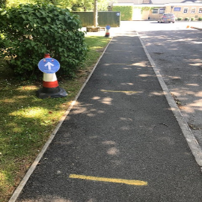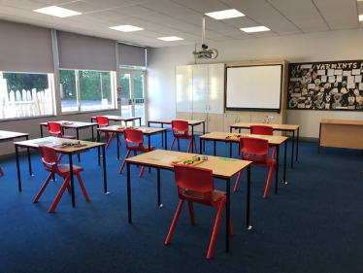

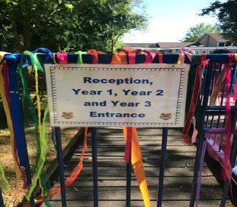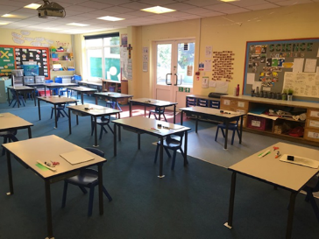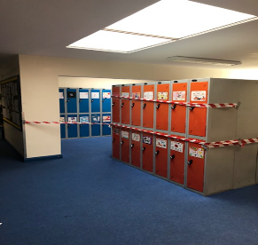

*Examples of how our school environment has been adapted to meet the requirements for social distancing and safety in schools.*

DROP OFF AND PICK UP ARRANGEMENTS

* At present, all children returning to school will start at 9am and finish at 3pm. This may change as the number of pupils continue to increase.
* Parents are asked to adhere to the social distancing 2m makers and signage in the school grounds.
* Only one adult per family is permitted onto school grounds to minimise traffic and footfall.
* When picking up children, parents are asked to stand in the socially distanced queue - the teacher will bring your child forward to the gate to meet you.

*Thanks to all who are adhering to the new system and making it work smoothly so far!*

COMMUNICATION WITH THE SCHOOL

* Parents are discouraged from conversations with staff at the gate as this interferes with the social distancing routines.
* Parents can of course, phone the school, or email [admin@st-patricks.wilts.sch.uk](mailto:admin@st-patricks.wilts.sch.uk) if you have any queries or would like a member of staff to get back to you.
* Mrs. Courtney, Miss McLoughlin or a member of the office team may be ‘loitering’ at the start and end of the day - you can obviously approach any member of staff who is not directly supervising children.

OTHER

* All children attending school will be provided with a picnic lunch to prevent cross contamination. Children will need to bring in a water bottle daily.
* Children should wear their PE kit (white T-shirt, black or navy shorts, daps or trainers - no open toed sandals). Public Health advice recommends that children wear clean clothes daily, as far as possible.
* With this very warm weather, children should bring in a sun hat for breaktimes. Please apply suncream in the morning. Whilst staff are not permitted to apply cream during the day, we will certainly supervise your children topping up their cream if you wish to send it in to school - labelled please!
* If your child has sensitive skin, you may wish to send in hand lotion which we can encourage your child to use - label please!

TO THOSE FAMILIES CONTINUING HOME LEARNING

* Teachers will continue to produce Home Learning packs weekly. If you require a hard copy, these will be available for collection from 10am each Monday - to avoid morning rush.
* Teachers will upload a video or blog weekly, to keep children connected.
* A weekly newsletter fro children will be uploaded on the Welcome Page of the website each Wednesday - there is an Animal Quiz this week too!
* Please do not hesitate to contact the school if you have any queries or worries.

*Keep up the good work!!*

Attached to this letter is a booklet for children called ‘Coming Back to School in a Bubble’ which may be helpful to read with your child. I also attach the previously circulated Wiltshire Council booklet to help parents and carers prepare children for a positive return to school.

Welcome to this very different Term 6. Stay safe. Stay in touch. Stay positive!

*R.E. McLoughlin J. Courtney Mrs. M. Ellis*

*Executive Headteacher Headteacher Designate Chair of Governors*