Thursday 2nd April 2020

Dear Parents,

COVID - 19 SCHOOL UPDATE

I hope that you are adjusting to our ‘new normal’ circumstances as we respond to the Government’s strict guidelines for day to day behaviours and routines. As you know, school is all but closed except to a number of children of key workers. Numbers vary from day to day as parents heed the advice to - if at all possible - keep children at home.

We hope that you have found the bundle of work prepared by the class teachers useful. We will be providing more work after the two week Easter break.

TERM 5 HOME LEARNING

Whilst the last fortnight’s home learning bundle was aimed to help you keep the children busy / entertained; provision for Term 5 will take a slightly different approach. We have worked to make it so that the learning is more progressive, is based on research (not wholly reliant on the internet), discussion and creativity. We will upload a weekly bank of learning for all subjects on Friday afternoon / evenings. We have worked to produce plans which do not rely heavily on you having to print off worksheets. Most tasks can be completed in the exercise books provided. We will signpost you to some webpages, but research and information books may be just as useful.

You can obviously determine your own weekly Home Learning timetable - When to work? How much to do? and that is why we will upload a week of work in one go rather than daily tasks. We will upload an answer page at the end of the week, as well as next week’s planning. Parents can obviously dip into any other year group’s work if you feel that the work set for their year group is too challenging for your child. The first week’s planner will be on the class website by the afternoon of Friday 17th April.

We will print off some copies of the weekly planning and leave them for collection in the lobby for those who do not have access to a printer or our website. These will be ready for collection from 10am each Monday morning.

We can also make new exercise books available for collection once your child has filled up their first book.

We have devised a sheet of additional websites or services which are offering free log on membership for parents during this period. Change4Life is a smashing website, and REAL PE is a scheme that we use in school which could be a good alternative if you are getting a little tired of The Body Coach!

SPECIAL EDUCATIONAL NEEDS PROVISION

Our SENCo, Mrs. Robertson has collated some valuable information for parents to support your working with children at home. This includes a contact list for the LA SSENs team, advice for working with pupils in Reception, Key Stage 1 and Key Stage 2, advice on Reading with your child, aiding concentration in learning, as well as working with children who may display some traits similar to those on the autism spectrum.

Obviously this information can be accessed and may be useful to all parents - not solely those whose child is ‘officially identified’ on the school’s SEN register. The information can be found under the ‘class pages’ tab of the school website.

COMMUNICATION

You may hear of schools who are setting up virtual learning systems to support learning at home. We have explored these and in fact, they are facing their own technical difficulties with this sudden global overload. In addition, we are not completely comfortable with some elements regarding child protection as well as safeguarding procedures for staff.

As a result, this is how we will communicate with you and your children -

* The class teacher will provide a weekly message or video on the class page.
* The school will contact a class of parents together on parentmail, when needed.
* Class teachers will phone each child’s family once during Term 5 to speak with parents and the child for a catch up.
* Parents can continue to contact the school any day by phone or email [admin@st-patricks.wilts.sch.uk](mailto:admin@st-patricks.wilts.sch.uk). There will be a member of the office team and a Senior Leader / Designated Safeguarding Lead in every day. We will be able to pass messages onto class teachers if necessary.

We attach a ‘catch up’ mini newsletter for all children with this letter.

Below are a couple of ‘recommended timetables’ which you may find helpful in planning your days - 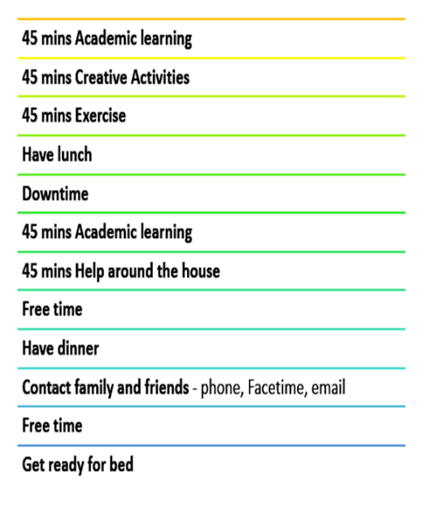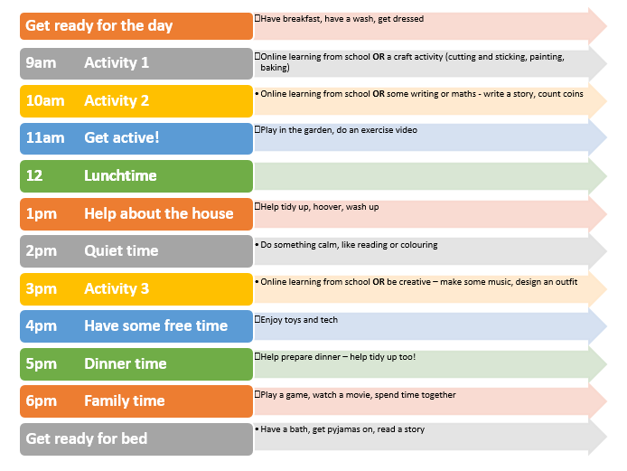

EASTER HOLIDAY PROVISION

Mrs. Courtney will have made contact with all relevant families this week. Whilst the school will not be open during the Easter break, we have made arrangements for children of workers who do need provision to go to Corsham Primary for the two weeks, excluding the two Bank Holidays. This is a different arrangement to term time school as places must be booked in advance (this Friday) through Saint Patrick’s.

We will not be providing Home Learning for Easter break, but we attach a series of alternative Easter Scavenger hunt ideas if you are at a loose end…..

FREE SCHOOL MEALS

On our return in Term 5, the school will continue to provide lunch daily for our children eligible for Free School meals, in addition to those children of key Workers and attending school also entitled to Universal (Key Stage 1) School meals. Lunch options are a jacket potato with cheese / ham or a cold packed lunch of ham / cheese sandwiches. Both options come with a yoghurt, fruit and biscuit / muffin / flapjack.

We will continue to leave out the cold packed lunches for those families eligible for Free School Meals who are self-isolating to come and collect daily.

Whilst there are some announcements about the voucher scheme, this has still not been made completely clear to schools and so, until such a time as this is completely comprehensive and robust, we will stick with our present arrangements which are completely reliable!

PUPIL ATTAINMENT AND PROGRESS

As you know, we should have held our Parent Consultation meetings this term, where we would inform you of your child’s progress to date, in addition to their targets and next steps for the second half of the year. Instead, our teaching staff are presently analysing the most recent assessment information which will equip them to write a Mid-Year Record of Achievement (formerly the end of year report) for your child which you will receive in the Summer term.



BEING WELL AND WELL-BEING

You need to look after YOU!

We attach two documents - one from Wiltshire Council and one from UNICEF - which we think are useful and uplifting - to support parents in supporting their children over coming weeks and months. We also attach a Children’s Guide to Coronavirus which we think is very helpful.

Do take time to care for yourself - you are the primary carers!

HOLY WEEK 2020

Attached is a document which gives updates from our local parishes, as well as signposting you to online Easter Services, activities for children and prayers etc.

*AND FINALLY……*



I know God carried us in March

and woke us to see April.

I pray everyday of April that He touches us

with good Health, Strength and Hope.

May God guide you and yours safely through each day with Love, Peace and Joy. Amen

*On behalf of all the staff of Saint Patrick’s school (self - isolating or not), we wish you a Happy, Holy and Healthy Easter break. Stay safe and well….*

Yours sincerely,

R.E. McLoughlin J. Courtney

Executive Headteacher Designate Headteacher