**Science Quiz - Answers**

1. Venus

2. Humerus

3. Filament

4. Refraction

5. Issac

6. The Milky Way galaxy

7. Charles Darwin

8. Plants

9. A star

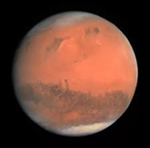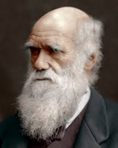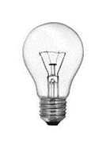10. Mars